|  |
| --- |
| **PROGRAM #1 03-02-2022** |
| Program for Login form using Modal |

<!DOCTYPE html>

<html>

<head>

<meta name="viewport" content="width=device-width, initial-scale=1">

<style>

body {font-family: Arial, Helvetica, sans-serif;}

input[type=text], input[type=password] {

  width: 100%;

  padding: 12px 20px;

  margin: 8px 0;

  display: inline-block;

  border: 1px solid #ccc;

  box-sizing: border-box;

}

button {

  background-color: #04AA6D;

  color: white;

  padding: 14px 20px;

  margin: 8px 0;

  border: none;

  cursor: pointer;

  width: 100%;

}

button:hover {

  opacity: 0.8;

}

.cancelbtn {

  width: auto;

  padding: 10px 18px;

  background-color: #f44336;

}

.imgcontainer {

  text-align: center;

  margin: 24px 0 12px 0;

  position: relative;

}

img.avatar {

  width: 40%;

  border-radius: 50%;

}

.container {

  padding: 16px;

}

span.psw {

  float: right;

  padding-top: 16px;

}

.modal {

  display: none;

  position: fixed;

  z-index: 1;

  left: 0;

  top: 0;

  width: 100%;

  height: 100%;

  overflow: auto;

  background-color: rgb(0,0,0);

  background-color: rgba(0,0,0,0.4);

  padding-top: 60px;

}

.modal-content {

  background-color: #fefefe;

  margin: 5% auto 15% auto;

  border: 1px solid #888;

  width: 80%; }

.close {

  position: absolute;

  right: 25px;

  top: 0;

  color: #000;

  font-size: 35px;

  font-weight: bold;

}

.close:hover,

.close:focus {

  color: red;

  cursor: pointer;

}

.animate {

  -webkit-animation: animatezoom 0.6s;

  animation: animatezoom 0.6s

}

@-webkit-keyframes animatezoom {

  from {-webkit-transform: scale(0)}

  to {-webkit-transform: scale(1)}

}

@keyframes animatezoom {

  from {transform: scale(0)}

  to {transform: scale(1)}

}

@media screen and (max-width: 300px) {

  span.psw {

     display: block;

     float: none;

  }

  .cancelbtn {

     width: 100%;

  }

}

</style>

</head>

<body>

<h2>Modal Login Form</h2>

<button onclick="document.getElementById('id01').style.display='block'" style="width:auto;">Login</button>

<div id="id01" class="modal">

  <form class="modal-content animate" action="/action_page.php" method="post">

    <div class="imgcontainer">

      <span onclick="document.getElementById('id01').style.display='none'" class="close" title="Close Modal">&times;</span>

         </div>

    <div class="container">

      <label for="uname"><b>Username</b></label>

      <input type="text" placeholder="Enter Username" name="uname" required>

      <label for="psw"><b>Password</b></label>

      <input type="password" placeholder="Enter Password" name="psw" required>

      <button type="submit">Login</button>

      <label>

        <input type="checkbox" checked="checked" name="remember"> Remember me

      </label>

    </div>

    <div class="container" style="background-color:#f1f1f1">

      <button type="button" onclick="document.getElementById('id01').style.display='none'" class="cancelbtn">Cancel</button>

      <span class="psw">Forgot <a href="#">password?</a></span>

    </div>

  </form>

</div>

<script>

// Get the modal

var modal = document.getElementById('id01');

// When the user clicks anywhere outside of the modal, close it

window.onclick = function(event) {

    if (event.target == modal) {

        modal.style.display = "none";

    }

}

</script>

</body>

</html>

**OUTPUT**

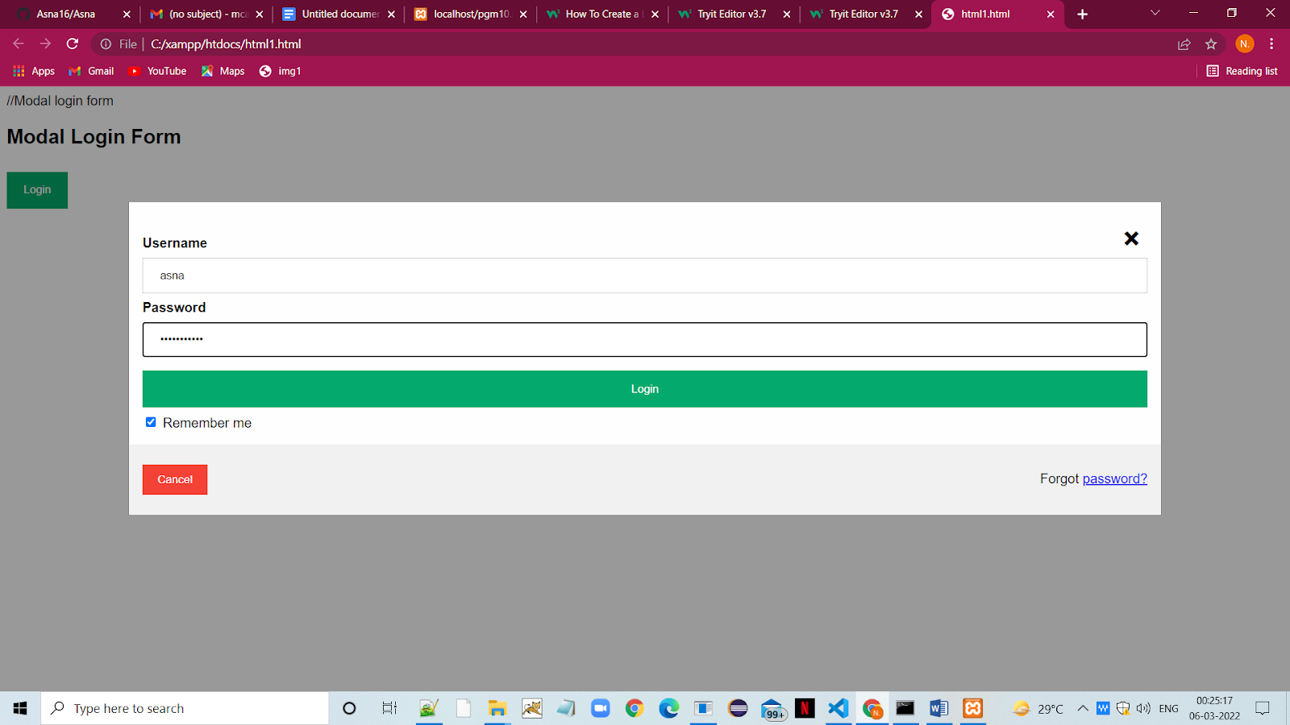

|  |
| --- |
| **PROGRAM #2 03-02-2022** |
| Program for Clickable dropdown |

<!DOCTYPE html>

<html>

<head>

<meta name="viewport" content="width=device-width, initial-scale=1">

<style>

.dropbtn {

  background-color: #3498DB;

  color: white;

  padding: 16px;

  font-size: 16px;

  border: none;

  cursor: pointer;

}

.dropbtn:hover, .dropbtn:focus {

  background-color: #2980B9;

}

.dropdown {

  position: relative;

  display: inline-block;

}

.dropdown-content {

  display: none;

  position: absolute;

  background-color: #f1f1f1;

  min-width: 160px;

  overflow: auto;

  box-shadow: 0px 8px 16px 0px rgba(0,0,0,0.2);

  z-index: 1;

}

.dropdown-content a {

  color: black;

  padding: 12px 16px;

  text-decoration: none;

  display: block;

}

.dropdown a:hover {background-color: #ddd;}

.show {display: block;}

</style>

</head>

<body>

<h2>Clickable Dropdown</h2>

<p>Click on the button to open the dropdown menu.</p>

<div class="dropdown">

  <button onclick="myFunction()" class="dropbtn">Dropdown</button>

  <div id="myDropdown" class="dropdown-content">

    <a href="#home">Home</a>

    <a href="#about">About</a>

    <a href="#contact">Contact</a>

  </div>

</div>

<script>

function myFunction() {

  document.getElementById("myDropdown").classList.toggle("show");

}

window.onclick = function(event) {

  if (!event.target.matches('.dropbtn')) {

    var dropdowns = document.getElementsByClassName("dropdown-content");

    var i;

    for (i = 0; i < dropdowns.length; i++) {

      var openDropdown = dropdowns[i];

      if (openDropdown.classList.contains('show')) {

        openDropdown.classList.remove('show');

      }

    }

  }

}

</script>

</body>

</html>

**OUTPUT**

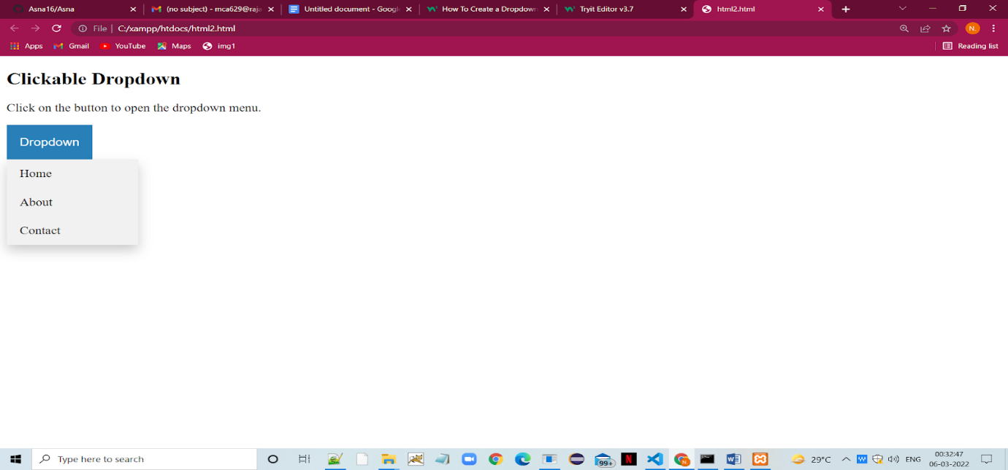

|  |
| --- |
| **PROGRAM #3 03-02-2022** |
| Program for Responsive top navbar |

<!DOCTYPE html>

<html>

<head>

<meta name="viewport" content="width=device-width, initial-scale=1">

<link rel="stylesheet" href="https://cdnjs.cloudflare.com/ajax/libs/font-awesome/4.7.0/css/font-awesome.min.css">

<style>

body {

  margin: 0;

  font-family: Arial, Helvetica, sans-serif;

}

.topnav {

  overflow: hidden;

  background-color: #333;

}

.topnav a {

  float: left;

  display: block;

  color: #f2f2f2;

  text-align: center;

  padding: 14px 16px;

  text-decoration: none;

  font-size: 17px;

}

.topnav a:hover {

  background-color: #ddd;

  color: black;

}

.topnav a.active {

  background-color: #04AA6D;

  color: white;

}

.topnav .icon {

  display: none;

}

@media screen and (max-width: 600px) {

  .topnav a:not(:first-child) {display: none;}

  .topnav a.icon {

    float: right;

    display: block;

  }

}

@media screen and (max-width: 600px) {

  .topnav.responsive {position: relative;}

  .topnav.responsive .icon {

    position: absolute;

    right: 0;

    top: 0;

  }

  .topnav.responsive a {

    float: none;

    display: block;

    text-align: left;

  }

}

</style>

</head>

<body>

<div class="topnav" id="myTopnav">

  <a href="#home" class="active">Home</a>

  <a href="#news">News</a>

  <a href="#contact">Contact</a>

  <a href="#about">About</a>

  <a href="javascript:void(0);" class="icon" onclick="myFunction()">

    <i class="fa fa-bars"></i>

  </a>

</div>

<div style="padding-left:16px">

  <h2>Responsive Topnav Example</h2>

  <p>Resize the browser window to see how it works.</p>

</div>

<script>

function myFunction() {

  var x = document.getElementById("myTopnav");

  if (x.className === "topnav") {

    x.className += " responsive";

  } else {

    x.className = "topnav";

  }

}

</script>

</body>

</html>

**OUTPUT**

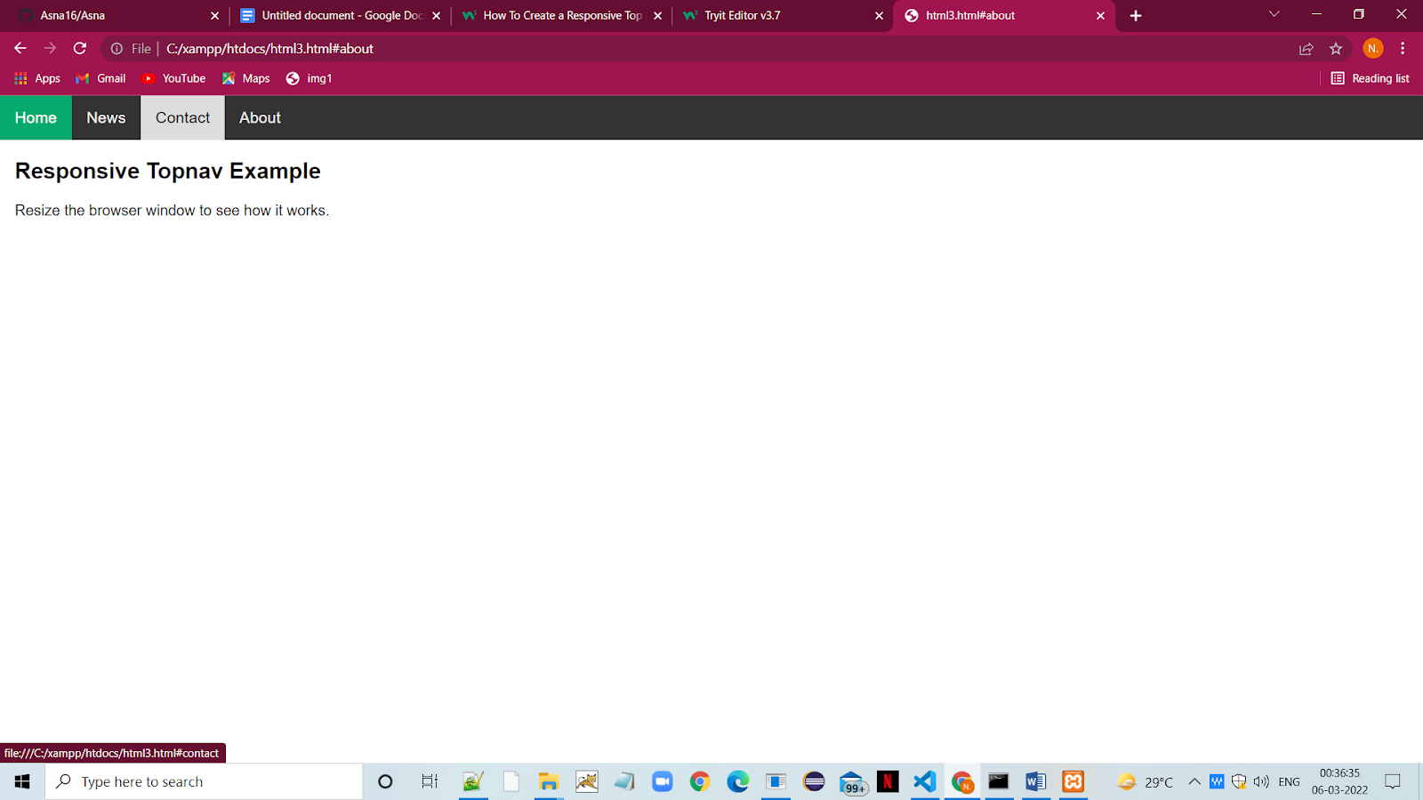

|  |
| --- |
| **PROGRAM #4 03-02-2022** |
| Program for Search Menu |

<!DOCTYPE html>

<html>

<head>

<meta name="viewport" content="width=device-width, initial-scale=1">

<style>

body {

  font-family: Arial, Helvetica, sans-serif;

}

* {

  box-sizing: border-box;

}

/* Create a column layout with Flexbox */

.row {

  display: flex;

}

/* Left column (menu) */

.left {

  flex: 35%;

  padding: 15px 0;

}

.left h2 {

  padding-left: 8px;

}

/* Right column (page content) */

.right {

  flex: 65%;

  padding: 15px;

}

/* Style the search box */

#mySearch {

  width: 100%;

  font-size: 18px;

  padding: 11px;

  border: 1px solid #ddd;

}

/* Style the navigation menu inside the left column */

#myMenu {

  list-style-type: none;

  padding: 0;

  margin: 0;

}

#myMenu li a {

  padding: 12px;

  text-decoration: none;

  color: black;

  display: block

}

#myMenu li a:hover {

  background-color: #eee;

}

</style>

</head>

<body>

<h2>Search Menu</h2>

<p>Start to type for a specific category inside the search bar to "filter" the search options.</p>

<div class="row">

  <div class="left" style="background-color:#bbb;">

    <h2>Menu</h2>

    <input type="text" id="mySearch" onkeyup="myFunction()" placeholder="Search.." title="Type in a category">

    <ul id="myMenu">

      <li><a href="#">HTML</a></li>

      <li><a href="#">CSS</a></li>

      <li><a href="#">JavaScript</a></li>

      <li><a href="#">PHP</a></li>

      <li><a href="#">Python</a></li>

      <li><a href="#">jQuery</a></li>

      <li><a href="#">SQL</a></li>

      <li><a href="#">Bootstrap</a></li>

      <li><a href="#">Node.js</a></li>

    </ul>

  </div>

  <div class="right" style="background-color:#ddd;">

    <h2>About Us</h2>

    <p>Reviews, client logos, case studies, and results bring consistency to your About Us page. It’s what really proves what you are saying is real and the impact you can bring to future clients.

With these components in mind, you will have a framework from which to build an engaging and unique About Us page.</p>

</div>

<script>

function myFunction() {

  var input, filter, ul, li, a, i;

  input = document.getElementById("mySearch");

  filter = input.value.toUpperCase();

  ul = document.getElementById("myMenu");

  li = ul.getElementsByTagName("li");

  for (i = 0; i < li.length; i++) {

    a = li[i].getElementsByTagName("a")[0];

    if (a.innerHTML.toUpperCase().indexOf(filter) > -1) {

      li[i].style.display = "";

    } else {

      li[i].style.display = "none";

    }

  }

}

</script>

</body>

</html>

**OUTPUT**

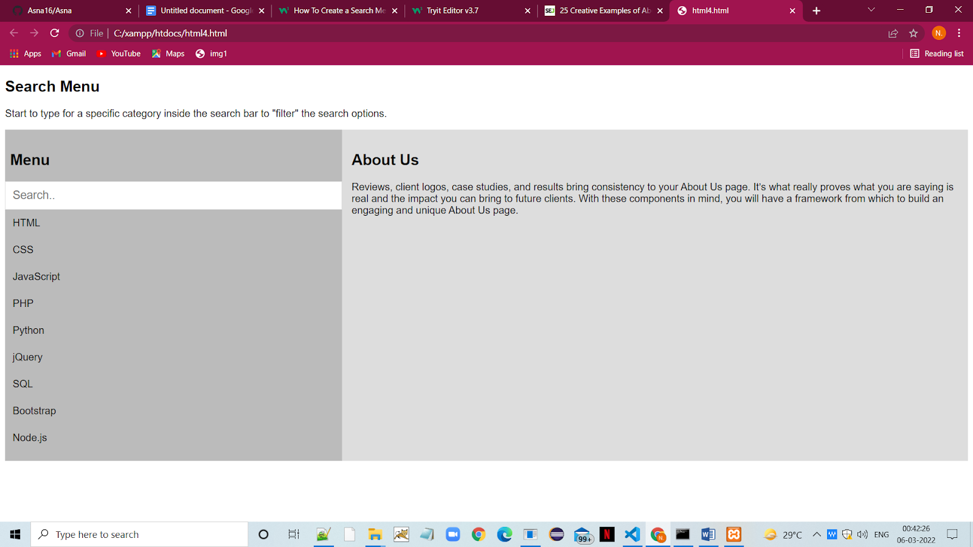

|  |
| --- |
| **PROGRAM #5 03-02-2022** |
| Program for Side-nav push |

<!DOCTYPE html>

<html>

<head>

<meta name="viewport" content="width=device-width, initial-scale=1">

<style>

body {

  font-family: "Lato", sans-serif;

}

.sidenav {

  height: 100%;

  width: 0;

  position: fixed;

  z-index: 1;

  top: 0;

  left: 0;

  background-color: #111;

  overflow-x: hidden;

  transition: 0.5s;

  padding-top: 60px;

}

.sidenav a {

  padding: 8px 8px 8px 32px;

  text-decoration: none;

  font-size: 25px;

  color: #818181;

  display: block;

  transition: 0.3s;

}

.sidenav a:hover {

  color: #f1f1f1;

}

.sidenav .closebtn {

  position: absolute;

  top: 0;

  right: 25px;

  font-size: 36px;

  margin-left: 50px;

}

#main {

  transition: margin-left .5s;

  padding: 16px;

}

@media screen and (max-height: 450px) {

  .sidenav {padding-top: 15px;}

  .sidenav a {font-size: 18px;}

}

</style>

</head>

<body>

<div id="mySidenav" class="sidenav">

  <a href="javascript:void(0)" class="closebtn" onclick="closeNav()">&times;</a>

  <a href="#">About</a>

  <a href="#">Services</a>

  <a href="#">Clients</a>

  <a href="#">Contact</a>

</div>

<div id="main">

  <h2>Sidenav Push Example</h2>

  <p>Click on the element below to open the side navigation menu, and push this content to the right.</p>

  <span style="font-size:30px;cursor:pointer" onclick="openNav()">&#9776; open</span>

</div>

<script>

function openNav() {

  document.getElementById("mySidenav").style.width = "250px";

  document.getElementById("main").style.marginLeft = "250px";

}

function closeNav() {

  document.getElementById("mySidenav").style.width = "0";

  document.getElementById("main").style.marginLeft= "0";

}

</script>

</body>

</html>

**OUTPUT**

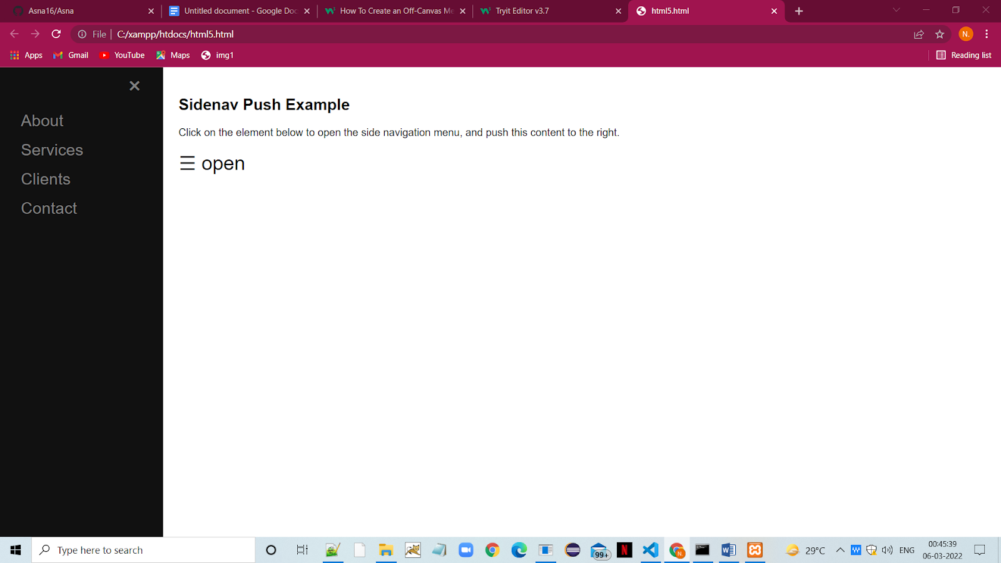

|  |
| --- |
| **PROGRAM #6 03-02-2022** |
| Program for Toggle like/dislike |

<!DOCTYPE html>

<html>

<head>

<link rel="stylesheet" href="https://cdnjs.cloudflare.com/ajax/libs/font-awesome/4.7.0/css/font-awesome.min.css">

<style>

.fa {

  font-size: 50px;

  cursor: pointer;

  user-select: none;

}

.fa:hover {

  color: darkblue;

}

</style>

</head>

<body>

<p>Click on the icon to toggle between thumbs-up and thumbs-down (like/dislike):</p>

<i onclick="myFunction(this)" class="fa fa-thumbs-up"></i>

<script>

function myFunction(x) {

  x.classList.toggle("fa-thumbs-down");

}

</script>

</body>

</html>

**OUTPUT**

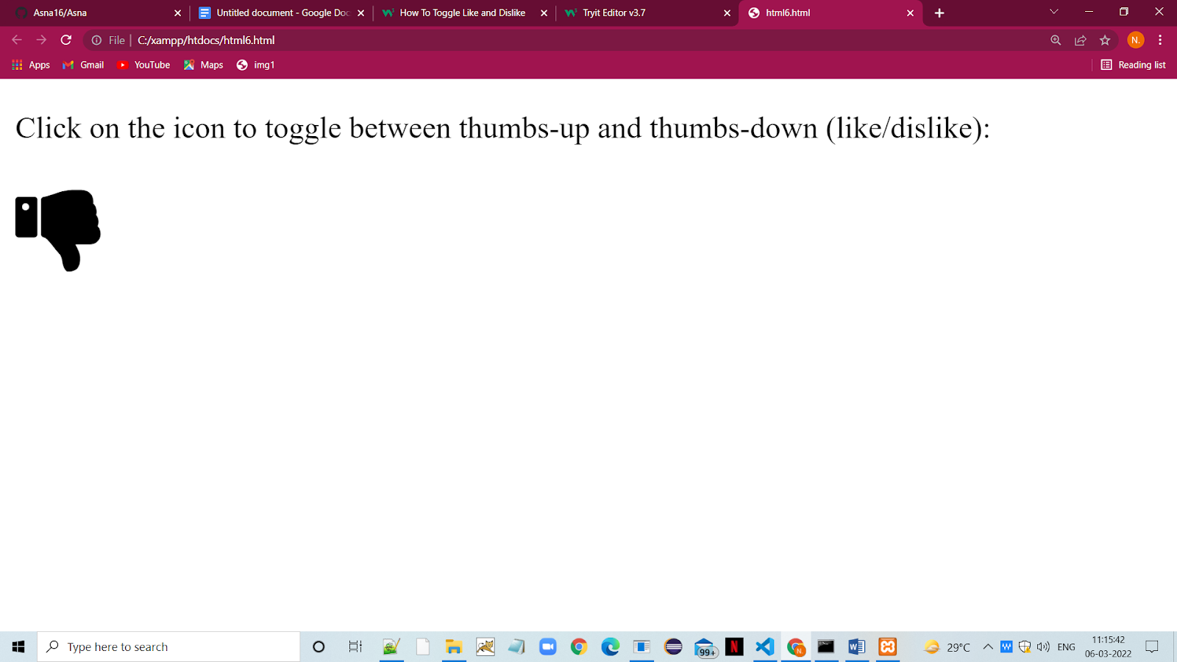

|  |
| --- |
| **PROGRAM #7 03-02-2022** |
| Program for Draggable HTML element |

<!DOCTYPE html>

<html>

<style>

#mydiv {

  position: absolute;

  z-index: 9;

  background-color: #f1f1f1;

  text-align: center;

  border: 1px solid #d3d3d3;

}

#mydivheader {

  padding: 10px;

  cursor: move;

  z-index: 10;

  background-color: #2196F3;

  color: #fff;

}

</style>

<body>

<h1>WELCOME TO MY PAGE</h1>

<p>Click and hold the mouse button down while moving the DIV element</p>

<div id="mydiv">

  <div id="mydivheader">Click here to move</div>

  <p>Home</p>

  <p>About Us</p>

  <p>Login</p>

</div>

<script>

function dragElement(elmnt) {

  var pos1 = 0, pos2 = 0, pos3 = 0, pos4 = 0;

  if (document.getElementById(elmnt.id + "header")) {

    /* if present, the header is where you move the DIV from:*/

    document.getElementById(elmnt.id + "header").onmousedown = dragMouseDown;

  } else {

    /* otherwise, move the DIV from anywhere inside the DIV:*/

    elmnt.onmousedown = dragMouseDown;

  }

  function dragMouseDown(e) {

    e = e || window.event;

    e.preventDefault();

    // get the mouse cursor position at startup:

    pos3 = e.clientX;

    pos4 = e.clientY;

    document.onmouseup = closeDragElement

    document.onmousemove = elementDrag;

  }

  function elementDrag(e) {

    e = e || window.event;

    e.preventDefault();

    // calculate the new cursor position:

    pos1 = pos3 - e.clientX;

    pos2 = pos4 - e.clientY;

    pos3 = e.clientX;

    pos4 = e.clientY;

    // set the element's new position:

    elmnt.style.top = (elmnt.offsetTop - pos2) + "px";

    elmnt.style.left = (elmnt.offsetLeft - pos1) + "px";

  }

  function closeDragElement() {

    /* stop moving when mouse button is released:*/

    document.onmouseup = null;

    document.onmousemove = null;

  }

}

</script>

</body>

</html>

**OUTPUT**

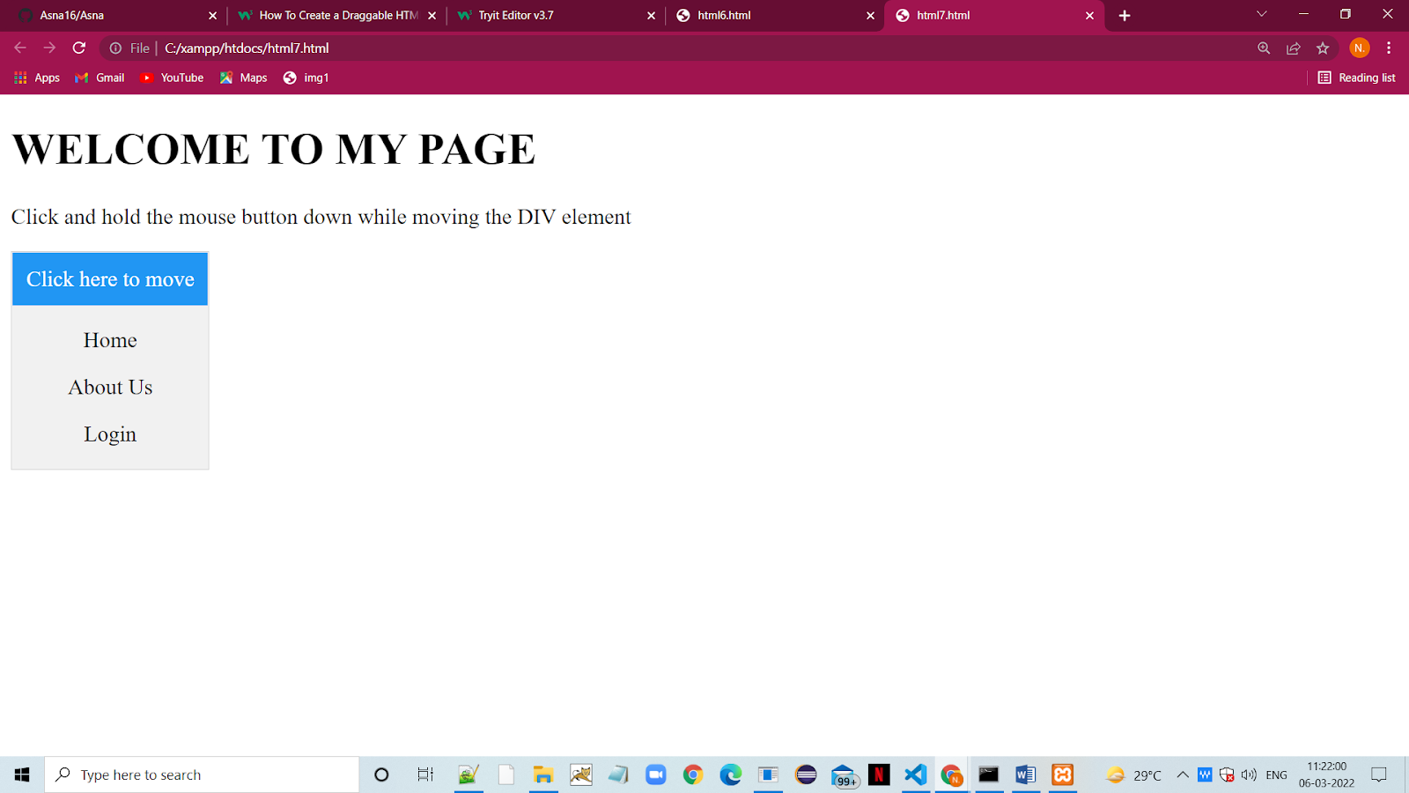

|  |
| --- |
| **PROGRAM #8 03-02-2022** |
| Program for Pop-up chat window |

<!DOCTYPE html>

<html>

<head>

<meta name="viewport" content="width=device-width, initial-scale=1">

<style>

body {font-family: Arial, Helvetica, sans-serif;}

* {box-sizing: border-box;}

.open-button {

  background-color: #555;

  color: white;

  padding: 16px 20px;

  border: none;

  cursor: pointer;

  opacity: 0.8;

  position: fixed;

  bottom: 23px;

  right: 28px;

  width: 280px;

}

.chat-popup {

  display: none;

  position: fixed;

  bottom: 0;

  right: 15px;

  border: 3px solid #f1f1f1;

  z-index: 9;

}

.form-container {

  max-width: 300px;

  padding: 10px;

  background-color: white;

}

.form-container textarea {

  width: 100%;

  padding: 15px;

  margin: 5px 0 22px 0;

  border: none;

  background: #f1f1f1;

  resize: none;

  min-height: 200px;

}

.form-container textarea:focus {

  background-color: #ddd;

  outline: none;

}

.form-container .btn {

  background-color: #04AA6D;

  color: white;

  padding: 16px 20px;

  border: none;

  cursor: pointer;

  width: 100%;

  margin-bottom:10px;

  opacity: 0.8;

}

.form-container .cancel {

  background-color: red;

}

.form-container .btn:hover, .open-button:hover {

  opacity: 1;

}

</style>

</head>

<body>

<h2>Ask The Doctor</h2>

<p>If you have any queries related to your health and the medicines,</p>

<p>then click on the below button to chat with your doctor.</p>

<button class="open-button" onclick="openForm()">Chat</button>

<div class="chat-popup" id="myForm">

  <form action="/action_page.php" class="form-container">

    <h1>Chat</h1>

    <label for="msg"><b>Message</b></label>

    <textarea placeholder="Type message.." name="msg" required></textarea>

    <button type="submit" class="btn">Send</button>

    <button type="button" class="btn cancel" onclick="closeForm()">Close</button>

  </form>

</div>

<script>

function openForm() {

  document.getElementById("myForm").style.display = "block";

}

function closeForm() {

  document.getElementById("myForm").style.display = "none";

}

</script>

</body>

</html>

**OUTPUT**

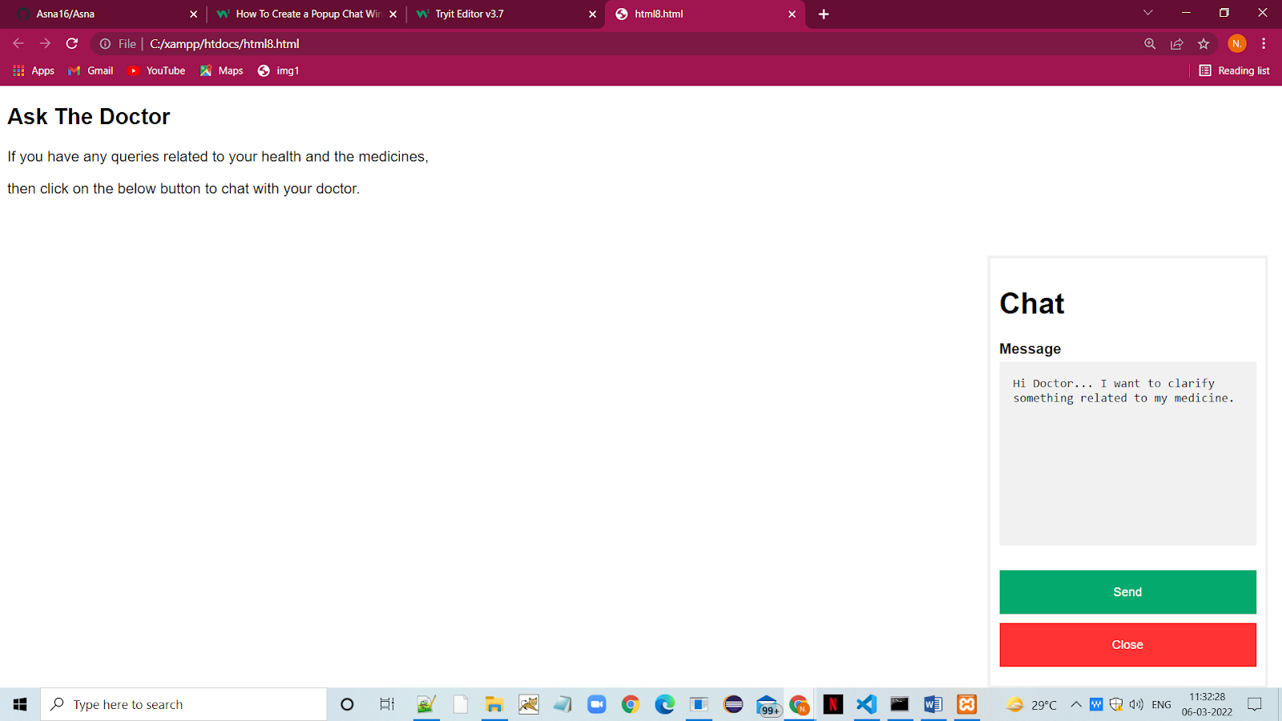

|  |
| --- |
| **PROGRAM #9 03-02-2022** |
| Program for Quotes Slideshow |

<!DOCTYPE html>

<html>

<head>

<meta name="viewport" content="width=device-width, initial-scale=1">

<style>

* {box-sizing: border-box}

body {font-family: Verdana, sans-serif; margin:0}

.slideshow-container {

  position: relative;

  background: #f1f1f1f1;

}

.mySlides {

  display: none;

  padding: 80px;

  text-align: center;

}

.prev, .next {

  cursor: pointer;

  position: absolute;

  top: 50%;

  width: auto;

  margin-top: -30px;

  padding: 16px;

  color: #888;

  font-weight: bold;

  font-size: 20px;

  border-radius: 0 3px 3px 0;

  user-select: none;

}

.next {

  position: absolute;

  right: 0;

  border-radius: 3px 0 0 3px;

}

.prev:hover, .next:hover {

  background-color: rgba(0,0,0,0.8);

  color: white;

}

.dot-container {

    text-align: center;

    padding: 20px;

    background: #ddd;

}

.dot {

  cursor: pointer;

  height: 15px;

  width: 15px;

  margin: 0 2px;

  background-color: #bbb;

  border-radius: 50%;

  display: inline-block;

  transition: background-color 0.6s ease;

}

.active, .dot:hover {

  background-color: #717171;

}

q {font-style: italic;}

.author {color: cornflowerblue;}

</style>

</head>

<body>

<div class="slideshow-container">

<div class="mySlides">

  <q>I love you the more in that I believe you had liked me for my own sake and for nothing else</q>

  <p class="author">- John Keats</p>

</div>

<div class="mySlides">

  <q>But man is not made for defeat. A man can be destroyed but not defeated.</q>

  <p class="author">- Ernest Hemingway</p>

</div>

<div class="mySlides">

  <q>I have not failed. I've just found 10,000 ways that won't work.</q>

  <p class="author">- Thomas A. Edison</p>

</div>

<a class="prev" onclick="plusSlides(-1)">❮</a>

<a class="next" onclick="plusSlides(1)">❯</a>

</div>

<div class="dot-container">

  <span class="dot" onclick="currentSlide(1)"></span>

  <span class="dot" onclick="currentSlide(2)"></span>

  <span class="dot" onclick="currentSlide(3)"></span>

</div>

<script>

var slideIndex = 1;

showSlides(slideIndex);

function plusSlides(n) {

  showSlides(slideIndex += n);

}

function currentSlide(n) {

  showSlides(slideIndex = n);

}

function showSlides(n) {

  var i;

  var slides = document.getElementsByClassName("mySlides");

  var dots = document.getElementsByClassName("dot");

  if (n > slides.length) {slideIndex = 1}

  if (n < 1) {slideIndex = slides.length}

  for (i = 0; i < slides.length; i++) {

      slides[i].style.display = "none";

  }

  for (i = 0; i < dots.length; i++) {

      dots[i].className = dots[i].className.replace(" active", "");

  }

  slides[slideIndex-1].style.display = "block";

  dots[slideIndex-1].className += " active";

}

</script>

</body>

</html>

**OUTPUT**

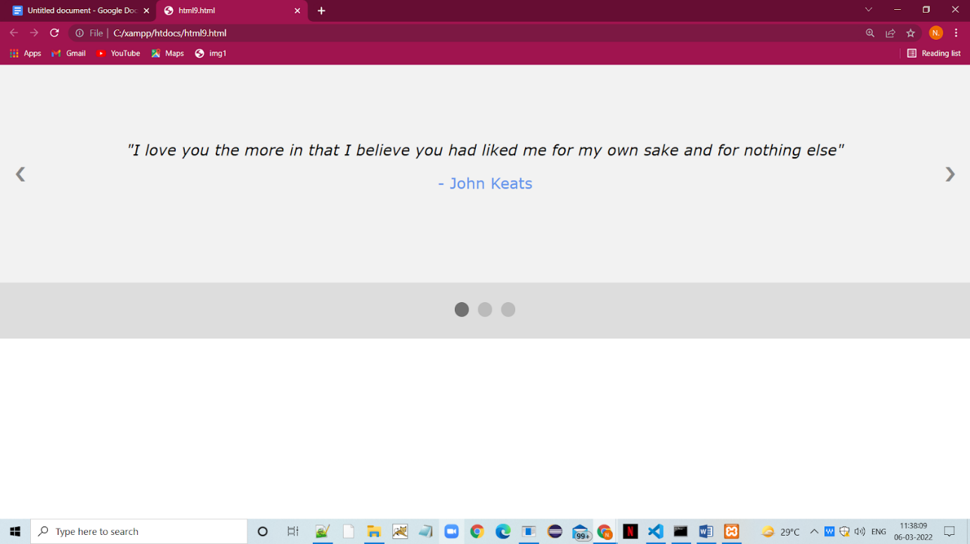

|  |
| --- |
| **PROGRAM #10 03-02-2022** |
| Program for Countdown Timer |

<!DOCTYPE HTML>

<html>

<head>

<meta name="viewport" content="width=device-width, initial-scale=1">

<style>

p {

  text-align: center;

  font-size: 60px;

  margin-top: 0px;

}

</style>

</head>

<body>

<p id="demo"></p>

<script>

// Set the date we're counting down to

var countDownDate = new Date("Jan 5, 2024 15:37:25").getTime();

// Update the count down every 1 second

var x = setInterval(function() {

  // Get today's date and time

  var now = new Date().getTime();

  // Find the distance between now and the count down date

  var distance = countDownDate - now;

  // Time calculations for days, hours, minutes and seconds

  var days = Math.floor(distance / (1000 * 60 * 60 * 24));

  var hours = Math.floor((distance % (1000 * 60 * 60 * 24)) / (1000 * 60 * 60));

  var minutes = Math.floor((distance % (1000 * 60 * 60)) / (1000 * 60));

  var seconds = Math.floor((distance % (1000 * 60)) / 1000);

  // Output the result in an element with id="demo"

  document.getElementById("demo").innerHTML = days + "d " + hours + "h "

  + minutes + "m " + seconds + "s ";

  // If the count down is over, write some text

  if (distance < 0) {

    clearInterval(x);

    document.getElementById("demo").innerHTML = "EXPIRED";

  }

}, 1000);

</script>

</body>

</html>

**OUTPUT**

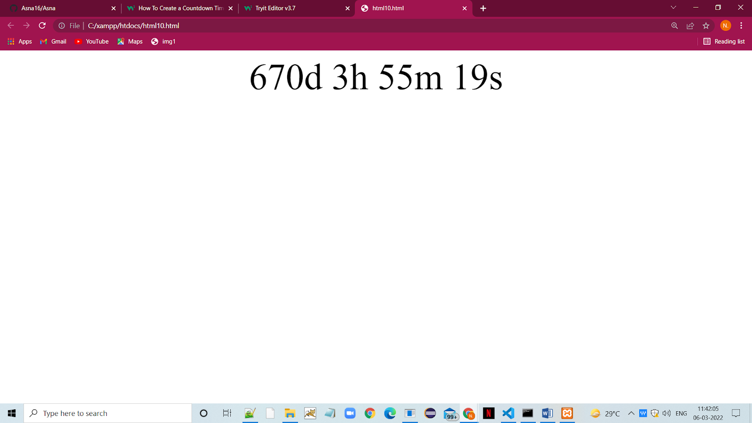

|  |
| --- |
| **PROGRAM #11 03-02-2022** |
| XML program to represent the books |

<?xml version="1.0" encoding="UTF-8"?>

<bookstore>

  <book category="cooking">

    <title lang="en">Everyday Italian</title>

    <author>Giada De Laurentiis</author>

    <year>2005</year>

    <price>30.00</price>

  </book>

  <book category="children">

    <title lang="en">Harry Potter</title>

    <author>J K. Rowling</author>

    <year>2005</year>

    <price>29.99</price>

  </book>

  <book category="web">

    <title lang="en">Learning XML</title>

    <author>Erik T. Ray</author>

    <year>2003</year>

    <price>39.95</price>

  </book>

</bookstore>

**OUTPUT**

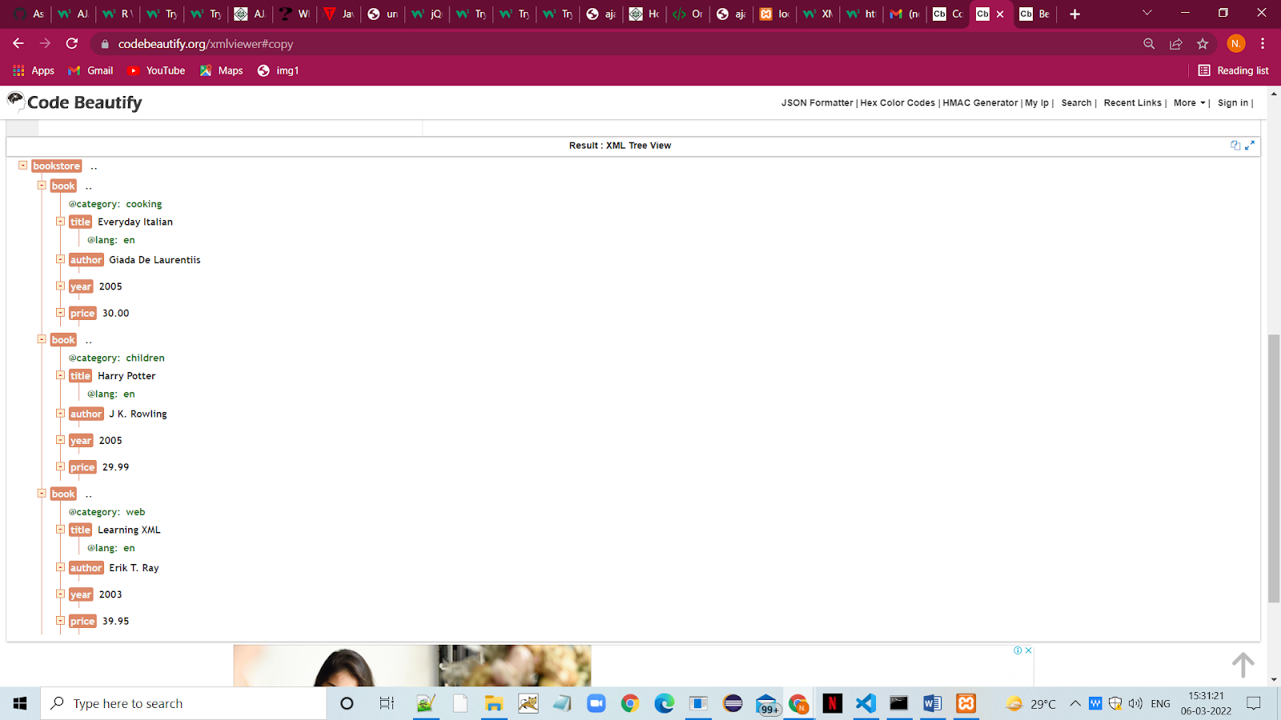

|  |
| --- |
| **PROGRAM #12 03-02-2022** |
| Program to represent the XML E-mails |

<?xml version="1.0" encoding="UTF-8"?>

<emails>

<email>

  <to>Shruthy</to>

  <from>Asna</from>

  <heading>Heyyy</heading>

  <body>Hello Best Friend, how are you?!</body>

</email>

<email>

  <to>Asna</to>

  <from>Abhirami</from>

  <heading>Health is Wealth</heading>

  <body>Please start morning walk to stay fit!</body>

</email>

<email>

  <to>Mariyam</to>

  <from>Asna</from>

  <heading>Your Special Day!</heading>

  <body>Happy Birthday!!!!</body>

</email>

</emails>

**OUTPUT**

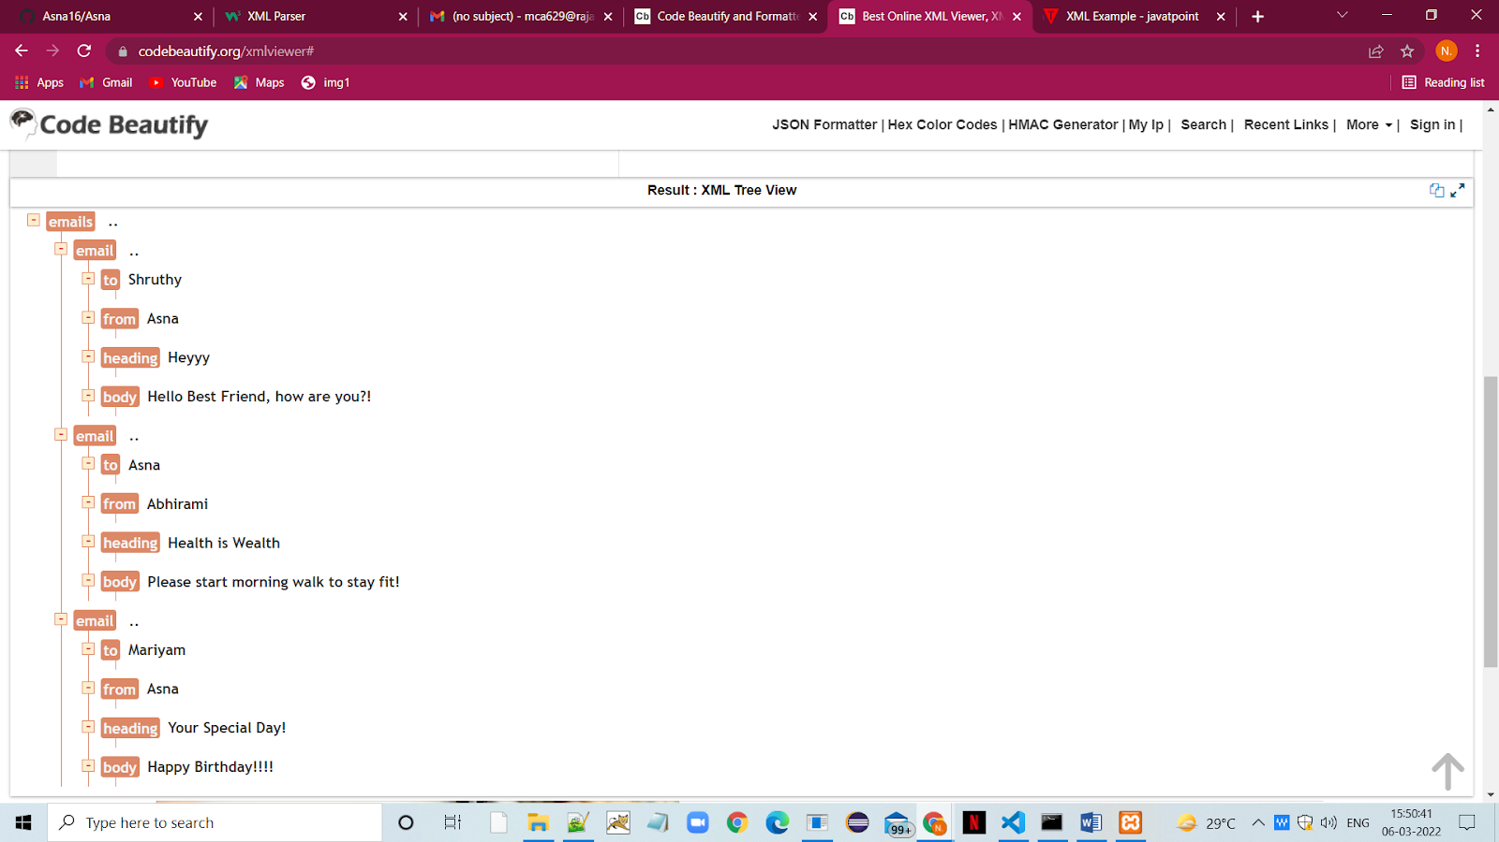

|  |
| --- |
| **PROGRAM #13 03-02-2022** |
| Program to represent the XML Plant Catalog |

<CATALOG>

<PLANT>

<COMMON>Bloodroot</COMMON>

<BOTANICAL>Sanguinaria canadensis</BOTANICAL>

<ZONE>4</ZONE>

<LIGHT>Mostly Shady</LIGHT>

<PRICE>$2.44</PRICE>

<AVAILABILITY>031599</AVAILABILITY>

</PLANT>

<PLANT>

<COMMON>Columbine</COMMON>

<BOTANICAL>Aquilegia canadensis</BOTANICAL>

<ZONE>3</ZONE>

<LIGHT>Mostly Shady</LIGHT>

<PRICE>$9.37</PRICE>

<AVAILABILITY>030699</AVAILABILITY>

</PLANT>

<PLANT>

<COMMON>Marsh Marigold</COMMON>

<BOTANICAL>Caltha palustris</BOTANICAL>

<ZONE>4</ZONE>

<LIGHT>Mostly Sunny</LIGHT>

<PRICE>$6.81</PRICE>

<AVAILABILITY>051799</AVAILABILITY>

</PLANT>

<PLANT>

<COMMON>Cowslip</COMMON>

<BOTANICAL>Caltha palustris</BOTANICAL>

<ZONE>4</ZONE>

<LIGHT>Mostly Shady</LIGHT>

<PRICE>$9.90</PRICE>

<AVAILABILITY>030699</AVAILABILITY>

</PLANT>

<PLANT>

<COMMON>Dutchman's-Breeches</COMMON>

<BOTANICAL>Dicentra cucullaria</BOTANICAL>

<ZONE>3</ZONE>

<LIGHT>Mostly Shady</LIGHT>

<PRICE>$6.44</PRICE>

<AVAILABILITY>012099</AVAILABILITY>

</PLANT>

</CATALOG>

**OUTPUT**

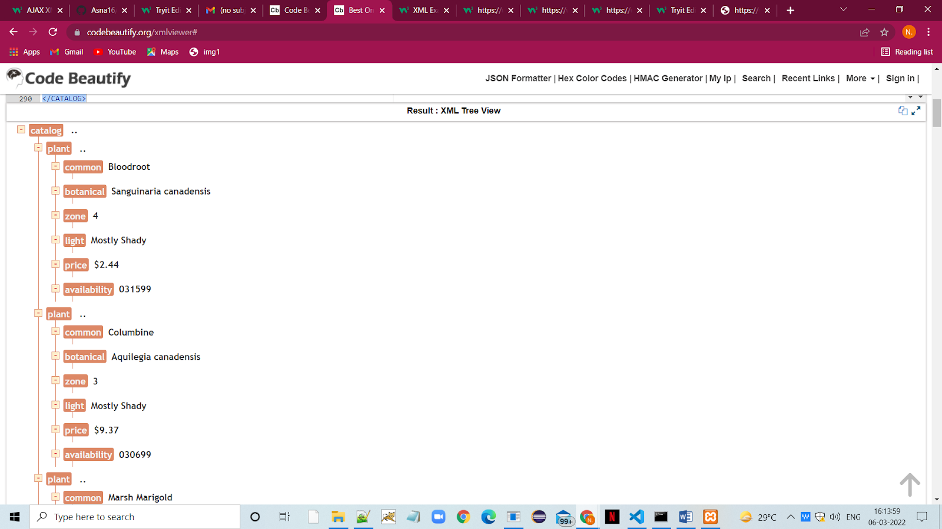

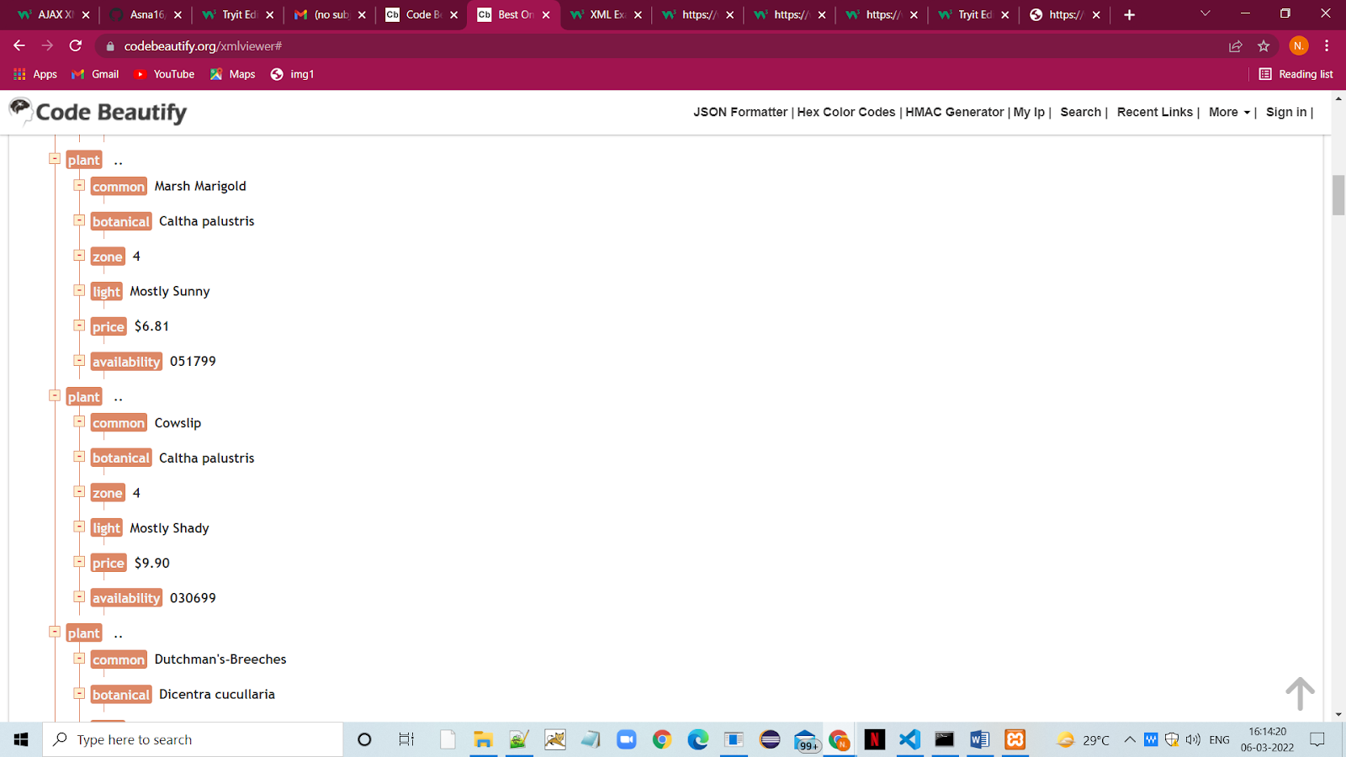

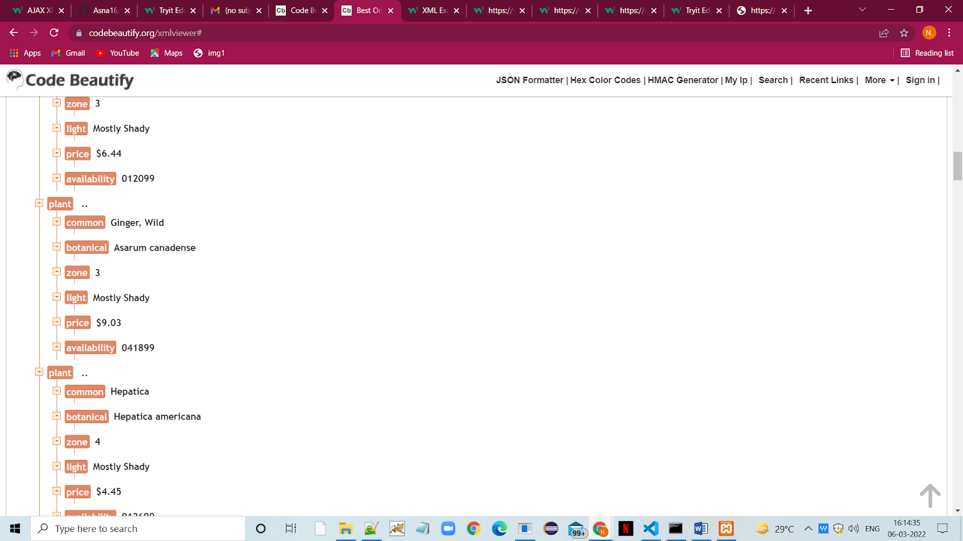

|  |
| --- |
| **PROGRAM #14 03-02-2022** |
| AJAX Program to display an alert box after the load () method completes. |

<!DOCTYPE html>

<html>

<head>

<script src="https://ajax.googleapis.com/ajax/libs/jquery/3.5.1/jquery.min.js"></script>

<script>

$(document).ready(function(){

  $("button").click(function(){

    $("#div1").load("demo_test.txt", function(responseTxt, statusTxt, xhr){

      if(statusTxt == "success")

        alert("External content loaded successfully!");

      if(statusTxt == "error")

        alert("Error: " + xhr.status + ": " + xhr.statusText);

    });

  });

});

</script>

</head>

<body>

<div id="div1"><h2>Let jQuery AJAX Change This Text</h2></div>

<button>Get External Content</button>

</body>

</html>

**OUTPUT**

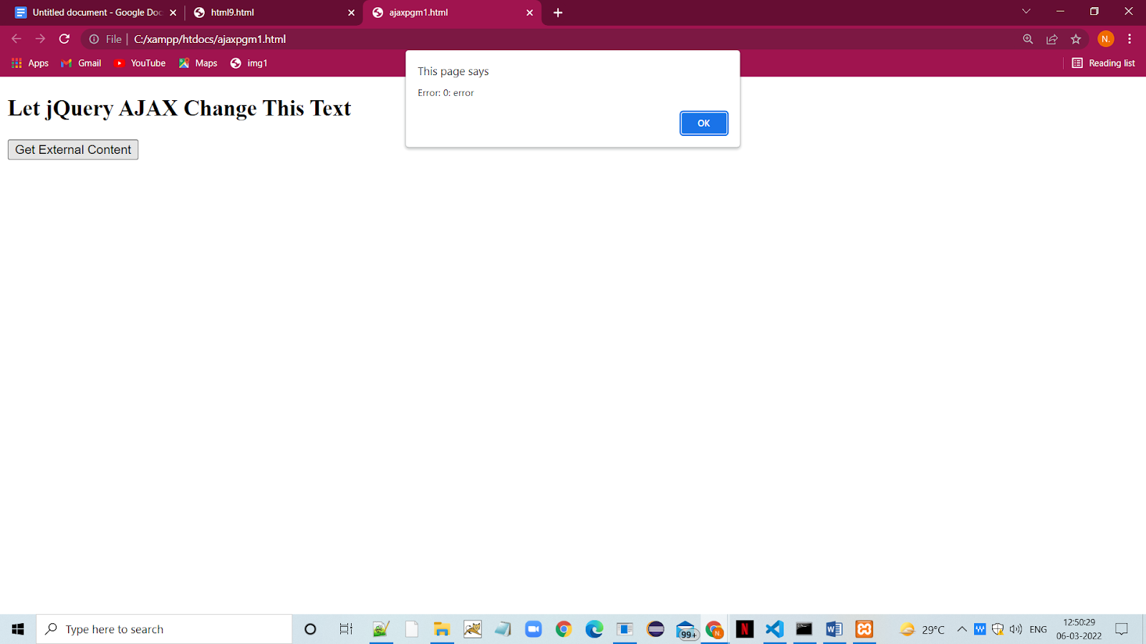

|  |
| --- |
| **PROGRAM #15 03-02-2022** |
| AJAX Program to hide the content using jQuery |

<!DOCTYPE html>

<html>

<head>

<script src="https://ajax.googleapis.com/ajax/libs/jquery/3.5.1/jquery.min.js"></script>

<script>

$(document).ready(function(){

  $("button").click(function(){

    $("p").hide(1000);

  });

});

</script>

</head>

<body>

<button>Hide</button>

<p>WELCOME TO MY NEW PAGE</p>

<p>CLICK ON THE ABOVE BUTTON TO HIDE THE CONTENT</p>

</body>

</html>

**OUTPUT**

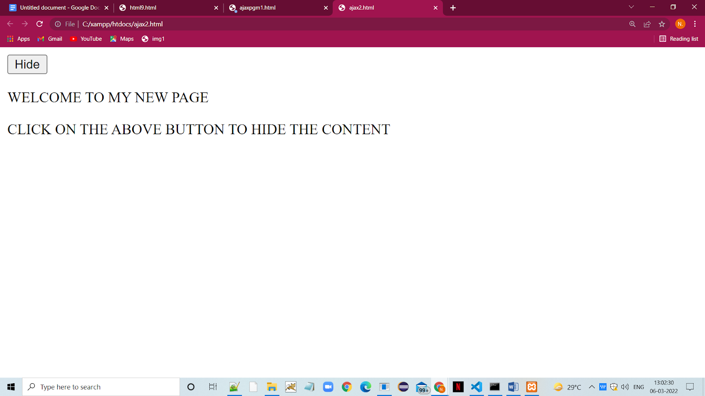

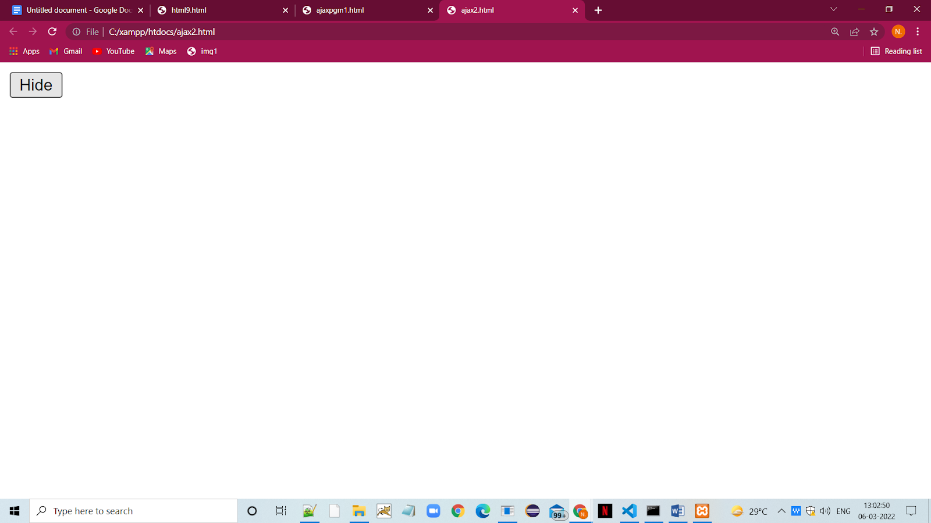

|  |
| --- |
| **PROGRAM #16 03-02-2022** |
| AJAX Program to add a class on click of anchor tag jQuery and addClass() method. |

<html>

   <head>

      <script src = "https://ajax.googleapis.com/ajax/libs/jquery/3.2.1/jquery.min.js"></script>

      <script>

      $(document).ready(function() {

        $("a").click(function() {

          $("a.active").removeClass("active");

          $(this).addClass("active");

        });

      });

      </script>

      <style>

      .active {

         font-size: 22px;

      }

      </style>

   </head>

   <body>

      <a href="#" class="">One</a>

      <a href="#" class="">Two</a>

      <p>Click any of the link above and you can see the changes.</p>

   </body>

</html>

**OUTPUT**

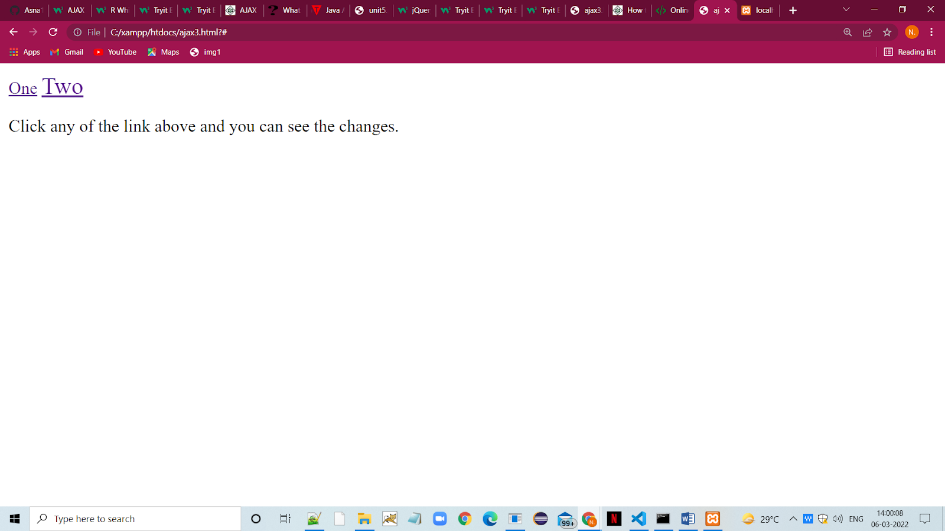

|  |
| --- |
| **PROGRAM #17 03-02-2022** |
| PHP program to print star triangle using for loop |

<?php

for($i=0;$i<=5;$i++){

for($j=5-$i;$j>=1;$j--){

echo "* ";

}

echo "<br>";

}

?>

**OUTPUT**

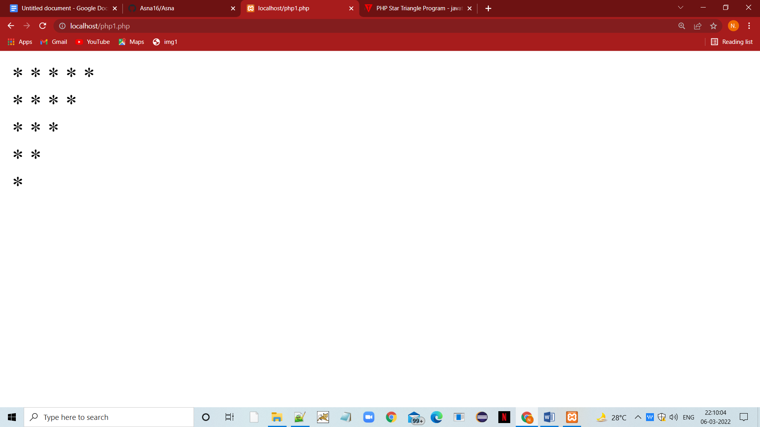

|  |
| --- |
| **PROGRAM #18 03-02-2022** |
| PHP program to print chess board. |

<!DOCTYPE html>

  <html>

  <head>

  <title></title>

  <meta http-equiv="Content-Type" content="text/html; charset=UTF-8">

  </head>

  <body>

  <h3>Chess Board using Nested For Loop</h3>

   <table width="270px" cellspacing="0px" cellpadding="0px" border="1px">

   <!-- cell 270px wide (8 columns x 60px) -->

   <?php

   for($row=1;$row<=8;$row++)

      {

       echo "<tr>";

       for($col=1;$col<=8;$col++)

      {

       $total=$row+$col;

       if($total%2==0)

      {

       echo "<td height=30px width=30px bgcolor=#FFFFFF></td>";

       }

      else

      {

       echo "<td height=30px width=30px bgcolor=#000000></td>";

       }

       }

       echo "</tr>";

}

       ?>

  </table>

  </body>

  </html>

**OUTPUT**

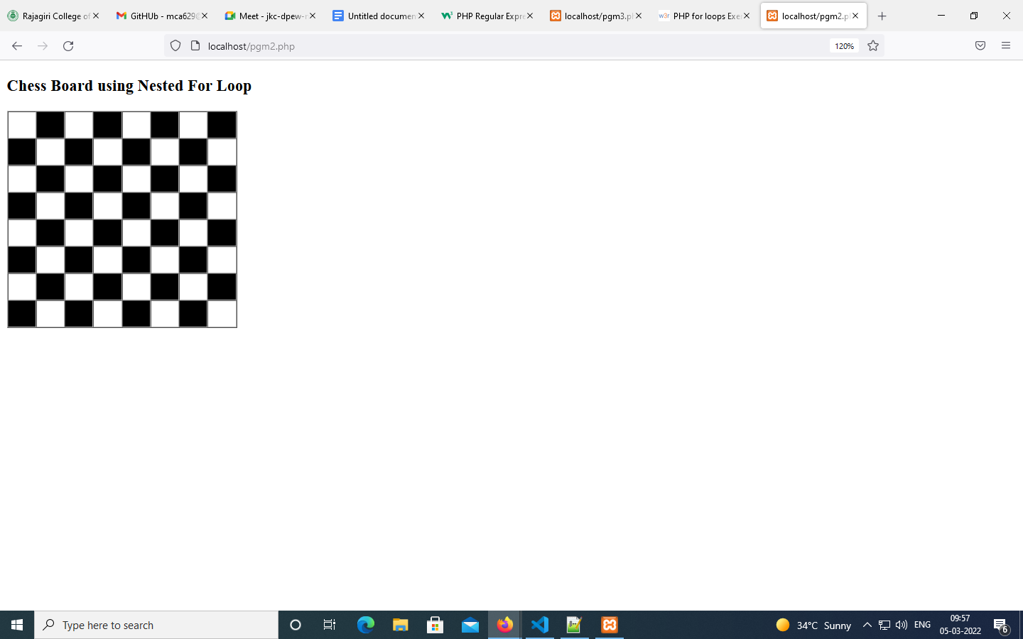

|  |
| --- |
| **PROGRAM #19 03-02-2022** |
| PHP program for Name,E-mail and URL validation. |

<!DOCTYPE HTML>

<html>

<head>

<style>

.error {color: #FF0000;}

</style>

</head>

<body>

<?php

// define variables and set to empty values

$nameErr = $emailErr = $genderErr = $websiteErr = "";

$name = $email = $gender = $comment = $website = "";

if ($_SERVER["REQUEST_METHOD"] == "POST") {

  if (empty($_POST["name"])) {

$nameErr = "Name is required";

  } else {

$name = test_input($_POST["name"]);

// check if name only contains letters and whitespace

if (!preg_match("/^[a-zA-Z-' ]*$/",$name)) {

   $nameErr = "Only letters and white space allowed";

}

  }

  if (empty($_POST["email"])) {

$emailErr = "Email is required";

  } else {

$email = test_input($_POST["email"]);

// check if e-mail address is well-formed

if (!filter_var($email, FILTER_VALIDATE_EMAIL)) {

   $emailErr = "Invalid email format";

}

  }

  if (empty($_POST["website"])) {

$website = "";

  } else {

$website = test_input($_POST["website"]);

// check if URL address syntax is valid

if (!preg_match("/\b(?:(?:https?|ftp):\/\/|www\.)[-a-z0-9+&@#\/%?=~_|!:,.;]*[-a-z0-9+&@#\/%=~_|]/i",$website)) {

   $websiteErr = "Invalid URL";

}

  }

  if (empty($_POST["comment"])) {

$comment = "";

  } else {

$comment = test_input($_POST["comment"]);

  }

  if (empty($_POST["gender"])) {

$genderErr = "Gender is required";

  } else {

$gender = test_input($_POST["gender"]);

  }

}

function test_input($data) {

  $data = trim($data);

  $data = stripslashes($data);

  $data = htmlspecialchars($data);

  return $data;

}

?>

<h2>PHP Form Validation Example</h2>

<p><span class="error">* required field</span></p>

<form method="post" action="<?php echo htmlspecialchars($_SERVER["PHP_SELF"]);?>">

  Name: <input type="text" name="name">

  <span class="error">* <?php echo $nameErr;?></span>

  <br><br>

  E-mail: <input type="text" name="email">

  <span class="error">* <?php echo $emailErr;?></span>

  <br><br>

  Website: <input type="text" name="website">

  <span class="error"><?php echo $websiteErr;?></span>

  <br><br>

  Comment: <textarea name="comment" rows="5" cols="40"></textarea>

  <br><br>

  Gender:

  <input type="radio" name="gender" value="female">Female

  <input type="radio" name="gender" value="male">Male

  <input type="radio" name="gender" value="other">Other

  <span class="error">* <?php echo $genderErr;?></span>

  <br><br>

  <input type="submit" name="submit" value="Submit">

</form>

<?php

echo "<h2>Your Input:</h2>";

echo $name;

echo "<br>";

echo $email;

echo "<br>";

echo $website;

echo "<br>";

echo $comment;

echo "<br>";

echo $gender;

?>

</body>

</html>

**OUTPUT**

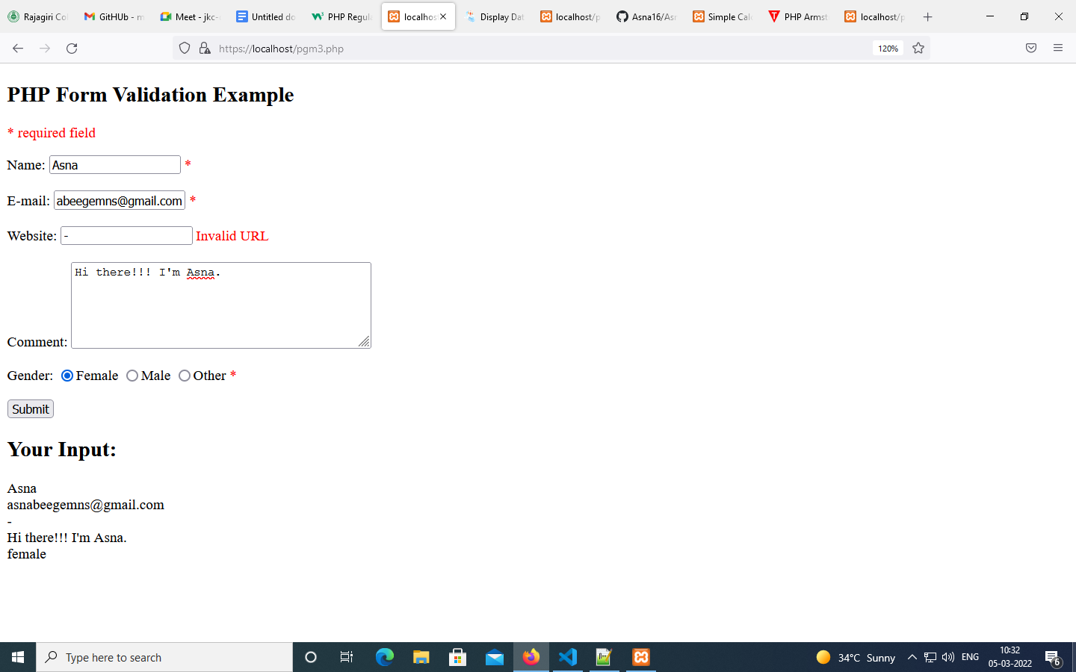

|  |
| --- |
| **PROGRAM #20 03-02-2022** |
| PHP program for Simple Calculator using Switch Case. |

<!DOCTYPE html>

<head>

    <title>Simple Calculator Program in PHP - Tutorials Class</title>

</head>

<?php

$first_num = $_POST['first_num'];

$second_num = $_POST['second_num'];

$operator = $_POST['operator'];

$result = '';

if (is_numeric($first_num) && is_numeric($second_num)) {

switch ($operator) {

     case "Add":

        $result = $first_num + $second_num;

         break;

     case "Subtract":

        $result = $first_num - $second_num;

         break;

     case "Multiply":

         $result = $first_num * $second_num;

         break;

     case "Divide":

         $result = $first_num / $second_num;

}

}

?>

<body>

<div id="page-wrap">

    <h1>PHP - Simple Calculator Program</h1>

      <form action="" method="post" id="quiz-form">

         <p>

             <input type="number" name="first_num" id="first_num" required="required" value="<?php echo $first_num; ?>" /> <b>First Number</b>

         </p>

         <p>

             <input type="number" name="second_num" id="second_num" required="required" value="<?php echo $second_num; ?>" /> <b>Second Number</b>

         </p>

         <p>

             <input readonly="readonly" name="result" value="<?php echo $result; ?>"> <b>Result</b>

         </p>

         <input type="submit" name="operator" value="Add" />

         <input type="submit" name="operator" value="Subtract" />

         <input type="submit" name="operator" value="Multiply" />

         <input type="submit" name="operator" value="Divide" />

      </form>

</div>

</body>

</html>

**OUTPUT**

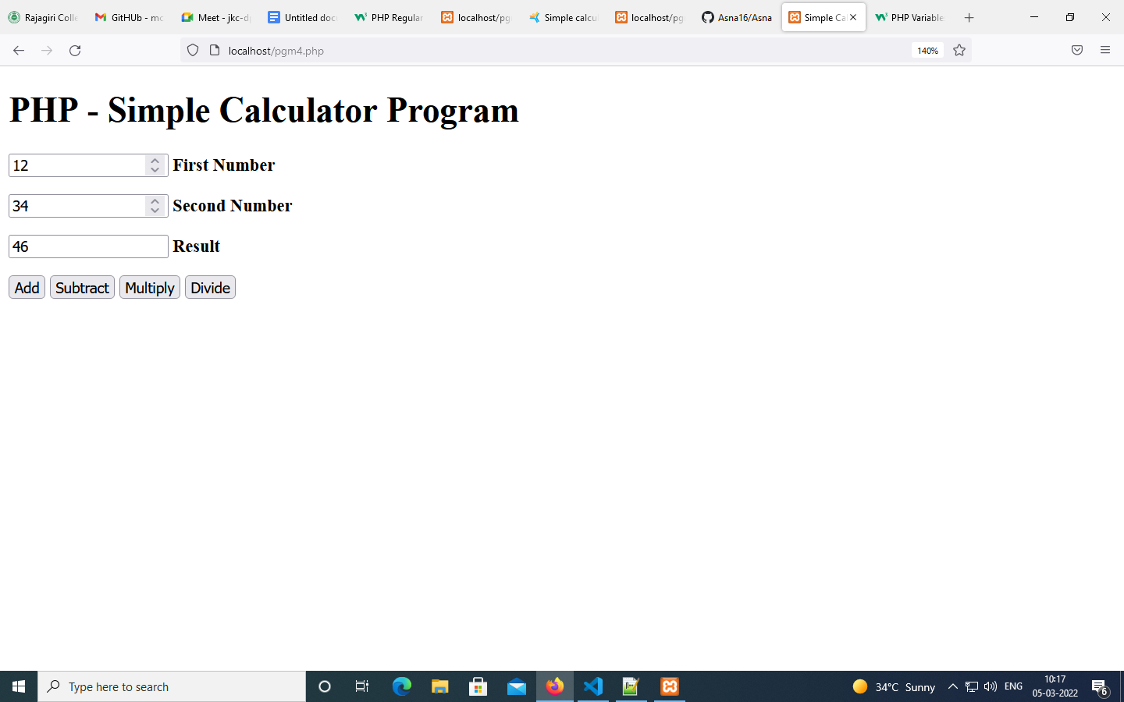

|  |
| --- |
| **PROGRAM #21 03-02-2022** |
| PHP program to check whether a number is Armstrong or not using form. |

<html>

<body>

  <form method="post">

  Enter the Number:

    <input type="number" name="number">

    <input type="submit" value="Submit">

   </form>

</body>

</html>

<?php

  if($_POST)

  {

   //get the number entered

   $number = $_POST['number'];

   //store entered number in a variable

   $a = $number;

   $sum  = 0;

   //run loop till the quotient is 0

   while( $a != 0 )

   {

    $rem   = $a % 10; //find reminder

    $sum   = $sum + ( $rem * $rem * $rem );    $a   = $a / 10;   }

   if( $number == $sum )

   {

    echo "Yes $number an Armstrong Number";

   }else

   {

    echo "$number is not an Armstrong Number";

   }

  }

?>

**OUTPUT**

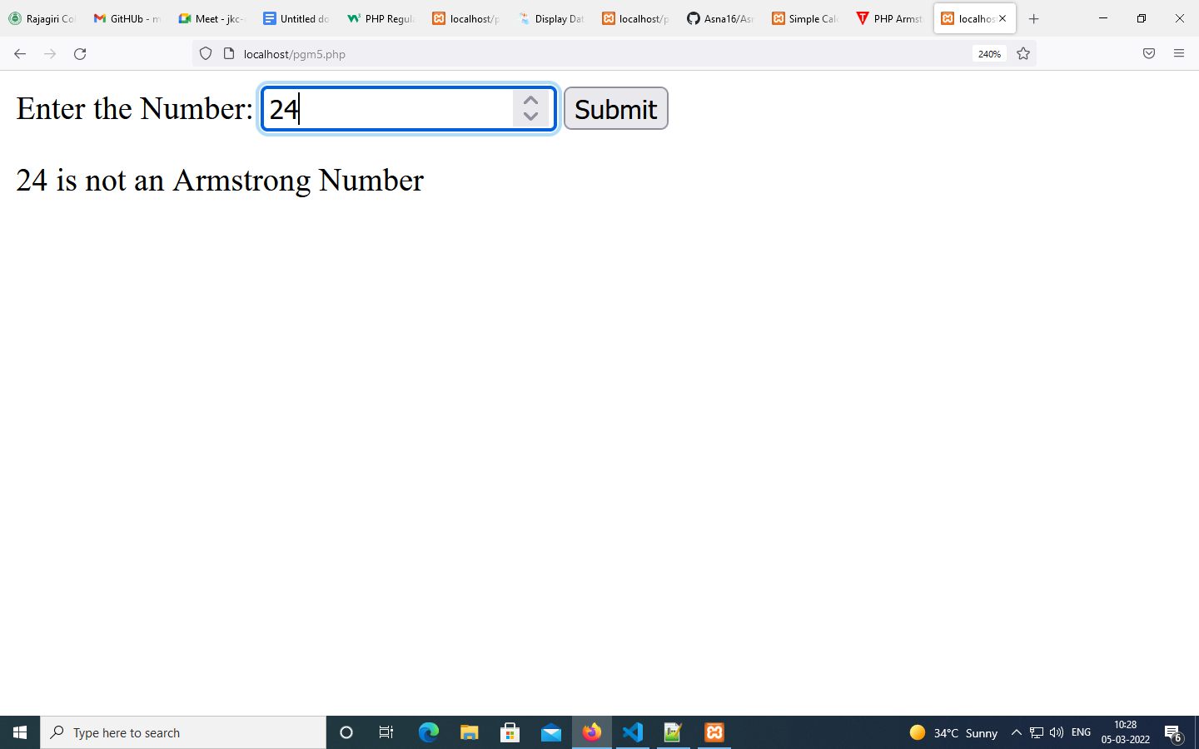

|  |
| --- |
| **PROGRAM #22 03-02-2022** |
| PHP program of cookie. |

<?php

setcookie("user", "asna");

?>

<html>

<body>

<?php

if(!isset($_COOKIE["user"])) {

     echo "Sorry, cookie is not found!";

} else {

     echo "<br/>Cookie Value: " . $_COOKIE["user"];

}

?>

</body>

</html>

**OUTPUT**

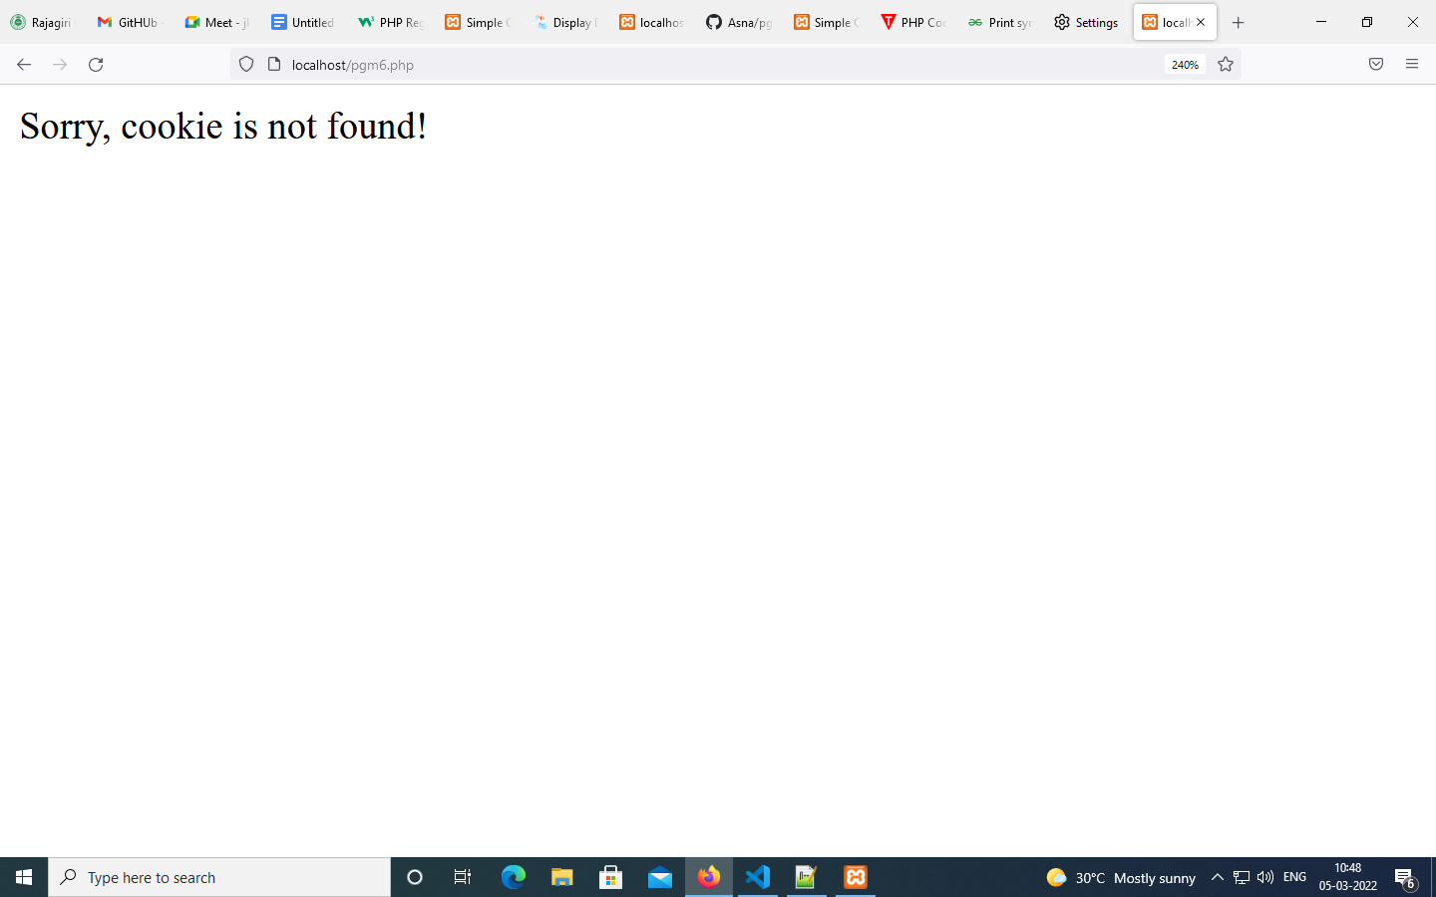

*Firstly cookie is not set. But, if you refresh the page, you will see cookie is set now.*

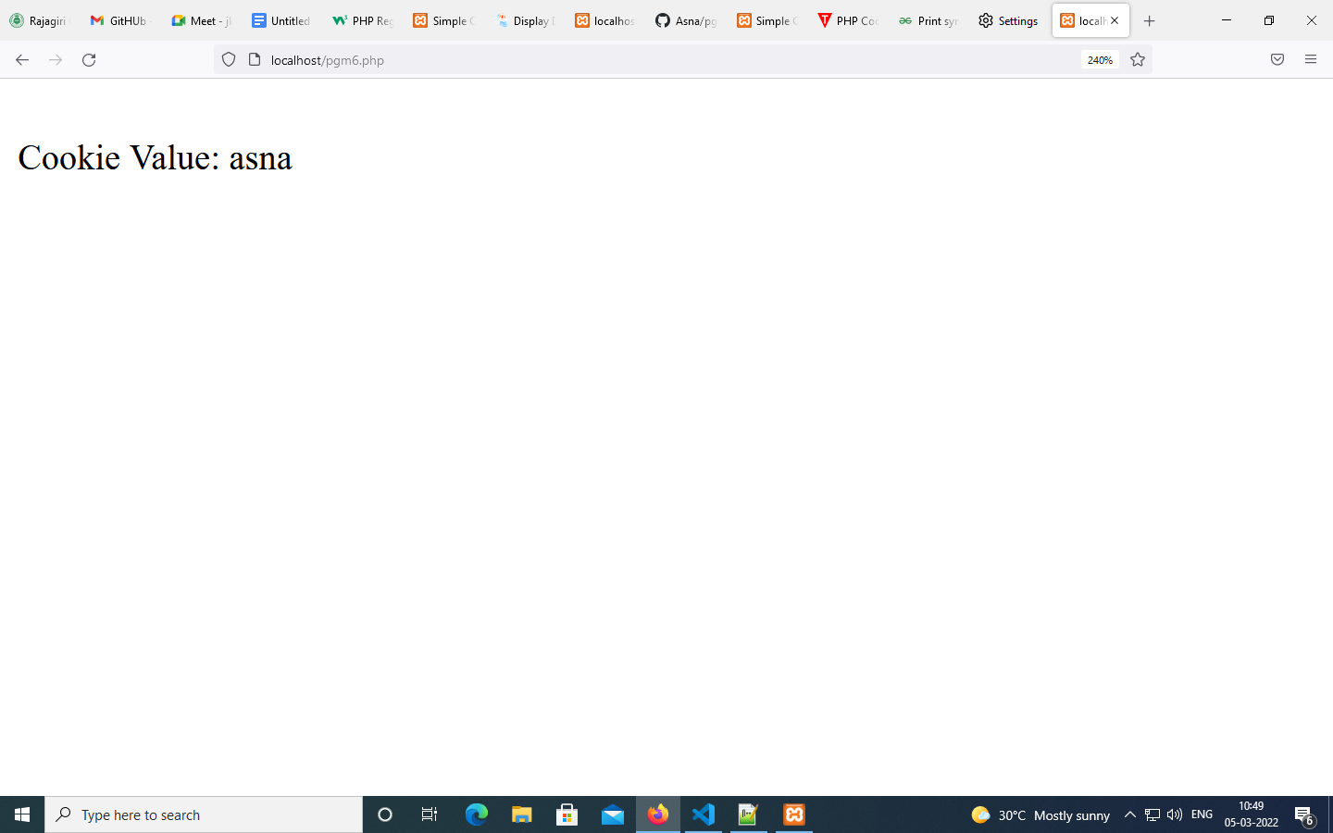

|  |
| --- |
| **PROGRAM #23 03-02-2022** |
| PHP program to display the leap years between 1991 and 2022. |

<?php

function isLeap($year)

{

    return (date('L', mktime(0, 0, 0, 1, 1, $year))==1);

}

//For testing

for($year=1991; $year<2022; $year++)

{

    If (isLeap($year))

    {

        echo "$year : LEAP YEAR<br />\n";

    }

    else

    {

        echo "$year : Not leap year<br />\n";

    }

}

?>

**OUTPUT**

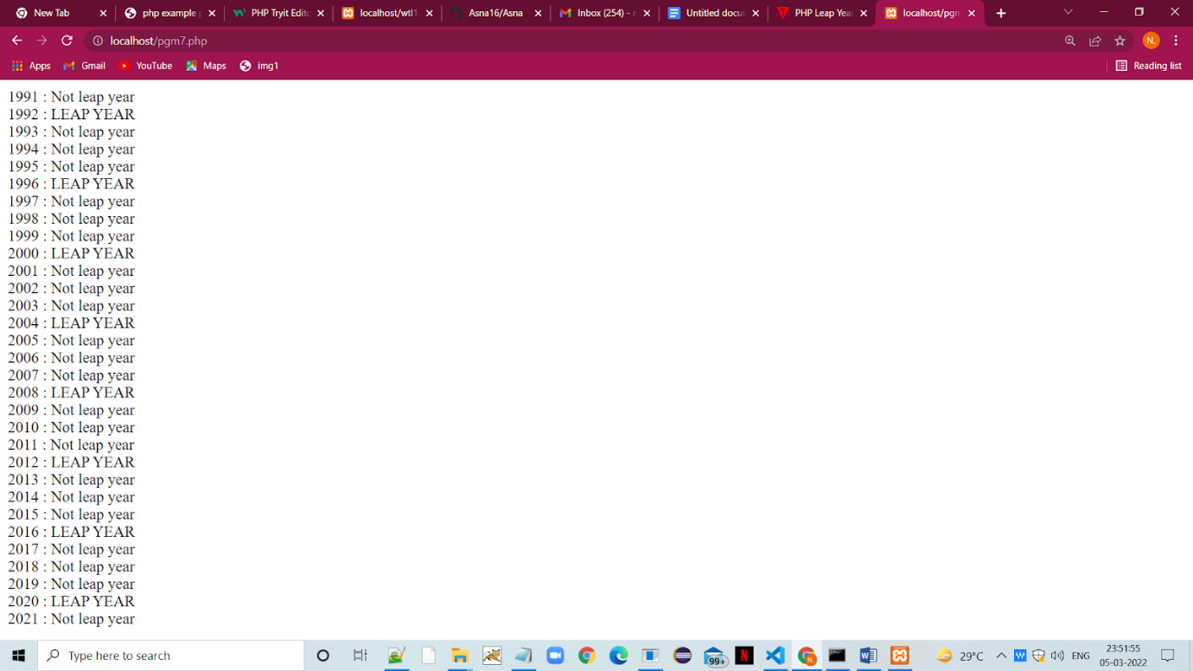

|  |
| --- |
| **PROGRAM #24 03-02-2022** |
| PHP program to  check whether the following strings are palindrome or not. |

<?php

function Palindrome($MyString) {

  $l = 0;

  $r = strlen($MyString) - 1;

  $flag = 0;

  while($r > $l){

    if ($MyString[$l] != $MyString[$r]){

      $flag = 1;

      break;

    }

    $l++;

    $r--;

  }

  if ($flag == 0){

    echo $MyString." is a Palindrome string.\n";

  } else {

    echo $MyString." is not a Palindrome string.\n";

  }

}

Palindrome("radar");

Palindrome("rubber");

Palindrome("malayalam");

?>

**OUTPUT**

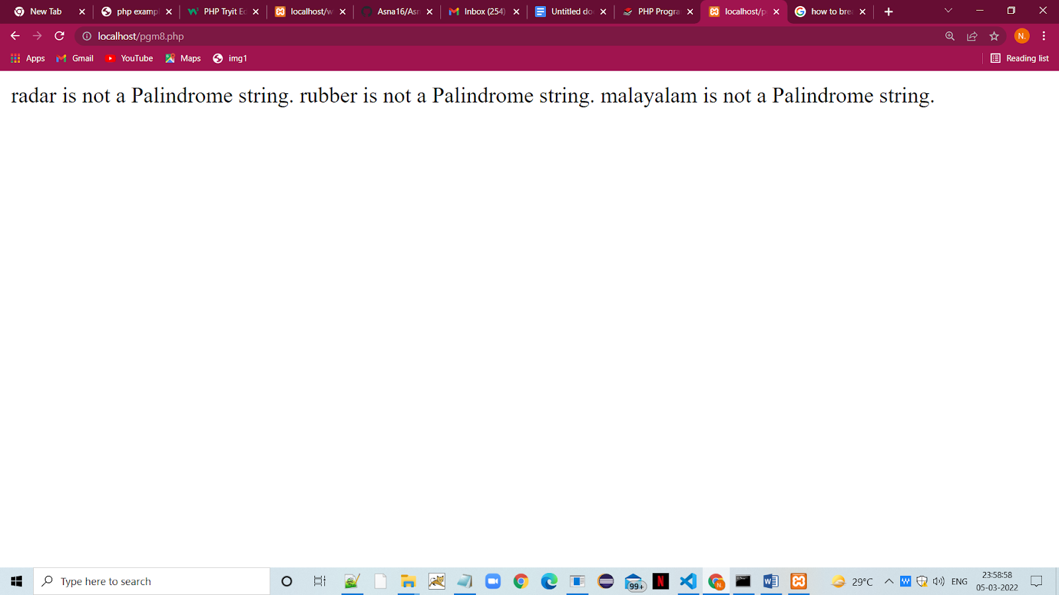

|  |
| --- |
| **PROGRAM #25 03-02-2022** |
| PHP program for insertion sort. |

<?php

function insertionsort(&$Array, $n) {

  for($i=0; $i<$n; $i++) {

    $curr = $Array[$i];

    $j = $i - 1;

    while($j >= 0 && $curr < $Array[$j]) {

      $Array[$j + 1] = $Array[$j];

      $Array[$j] = $curr;

      $j = $j - 1;

    }

  }

}

function PrintArray($Array, $n) {

  for ($i = 0; $i < $n; $i++)

    echo $Array[$i]." ";

  echo "\n";

}

$MyArray = array(1, 10, 23, 50, 4, 9, -4);

$n = sizeof($MyArray);

echo "Original Array\n";

PrintArray($MyArray, $n);

insertionsort($MyArray, $n);

echo "\nSorted Array\n";

PrintArray($MyArray, $n);

?>

**OUTPUT**

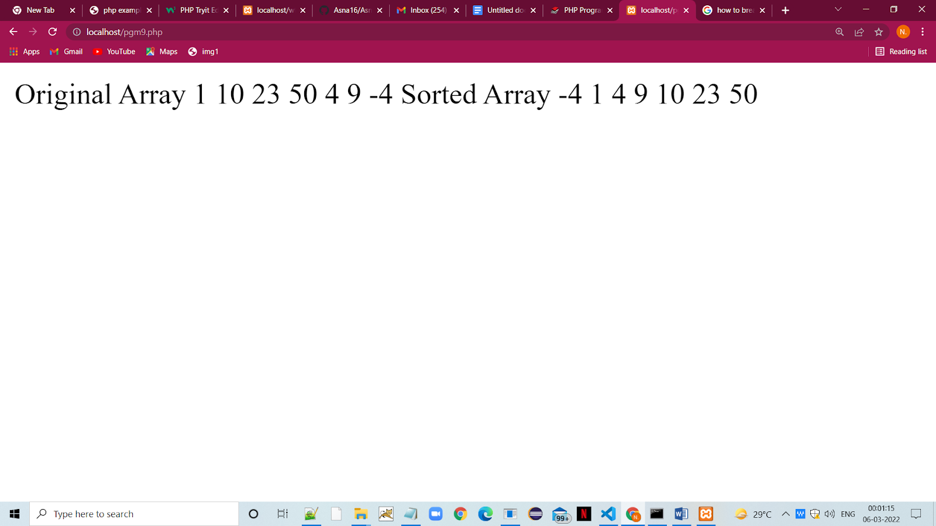

|  |
| --- |
| **PROGRAM #26 03-02-2022** |
| PHP program for merge sort. |

<?php

function mergesort(&$Array, $left, $right) {

  if ($left < $right) {

    $mid = $left + (int)(($right - $left)/2);

    mergesort($Array, $left, $mid);

    mergesort($Array, $mid+1, $right);

    merge($Array, $left, $mid, $right);

  }

}

function merge(&$Array, $left, $mid, $right) {

  $n1 = $mid - $left + 1; //no of elements in LeftArray

  $n2 = $right - $mid;     //no of elements in RightArray

  $LeftArray = array_fill(0, $n1, 0);

  $RightArray = array_fill(0, $n2, 0);

  for($i=0; $i < $n1; $i++) {

    $LeftArray[$i] = $Array[$left + $i];

  }

  for($i=0; $i < $n2; $i++) {

    $RightArray[$i] = $Array[$mid + $i + 1];

  }

  $x=0; $y=0; $z=$left;

  while($x < $n1 && $y < $n2) {

    if($LeftArray[$x] < $RightArray[$y]) {

      $Array[$z] = $LeftArray[$x];

      $x++;

    }

    else {

      $Array[$z] = $RightArray[$y];

      $y++;

    }

    $z++;

  }

  while($x < $n1) {

     $Array[$z] = $LeftArray[$x];

     $x++;

     $z++;

  }

  while($y < $n2) {

    $Array[$z] = $RightArray[$y];

    $y++;

    $z++;

  }

}

function PrintArray($Array, $n) {

  for ($i = 0; $i < $n; $i++)

    echo $Array[$i]." ";

  echo "\n";

}

$MyArray = array(10, 1, 23, 50, 4, 9, -4);

$n = sizeof($MyArray);

echo "Original Array\n";

PrintArray($MyArray, $n);

mergesort($MyArray, 0, $n-1);

echo "\nSorted Array\n";

PrintArray($MyArray, $n);

?>

**OUTPUT**

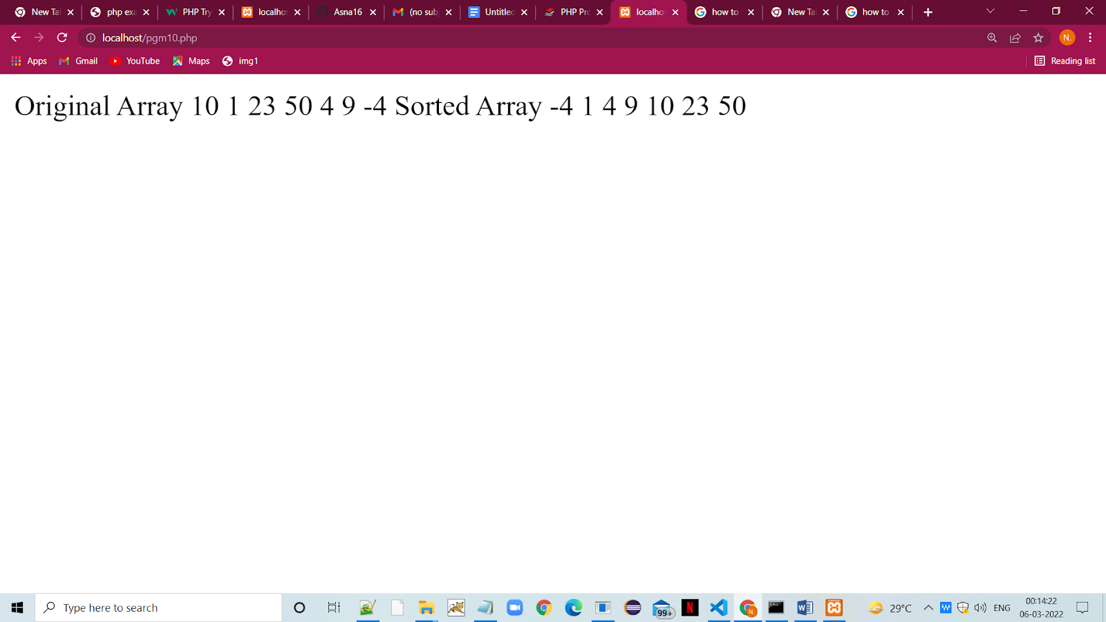

|  |
| --- |
| **PROGRAM #27 03-02-2022** |
| Program to represent JSON array. |

{

"employees": {

"employee": [

{

"name": "Shyam",

"email": "shyamjaiswal@gmail.com"

},

{

"name": "Bob",

"email": "bob32@gmail.com"

},

{

"name": "Jai",

"email": "jai87@gmail.com"

}

]

}

}</employees>

**OUTPUT**

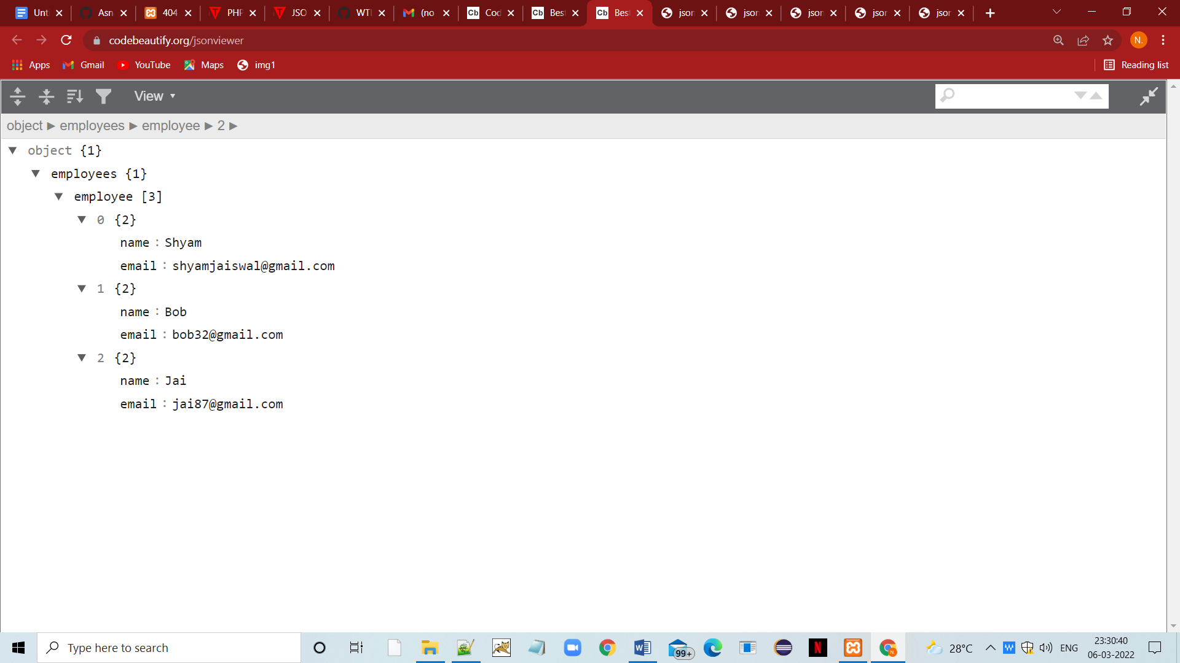

|  |
| --- |
| **PROGRAM #28 03-02-2022** |
| Program to represent JSON array having objects. |

{"menu":

{

"id": "file",

"value": "File",

"popup": {

"menuitem": [

{"value": "New", "onclick": "CreateDoc()"},

{"value": "Open", "onclick": "OpenDoc()"},

{"value": "Save", "onclick": "SaveDoc()"}

]

}

}}

**OUTPUT**

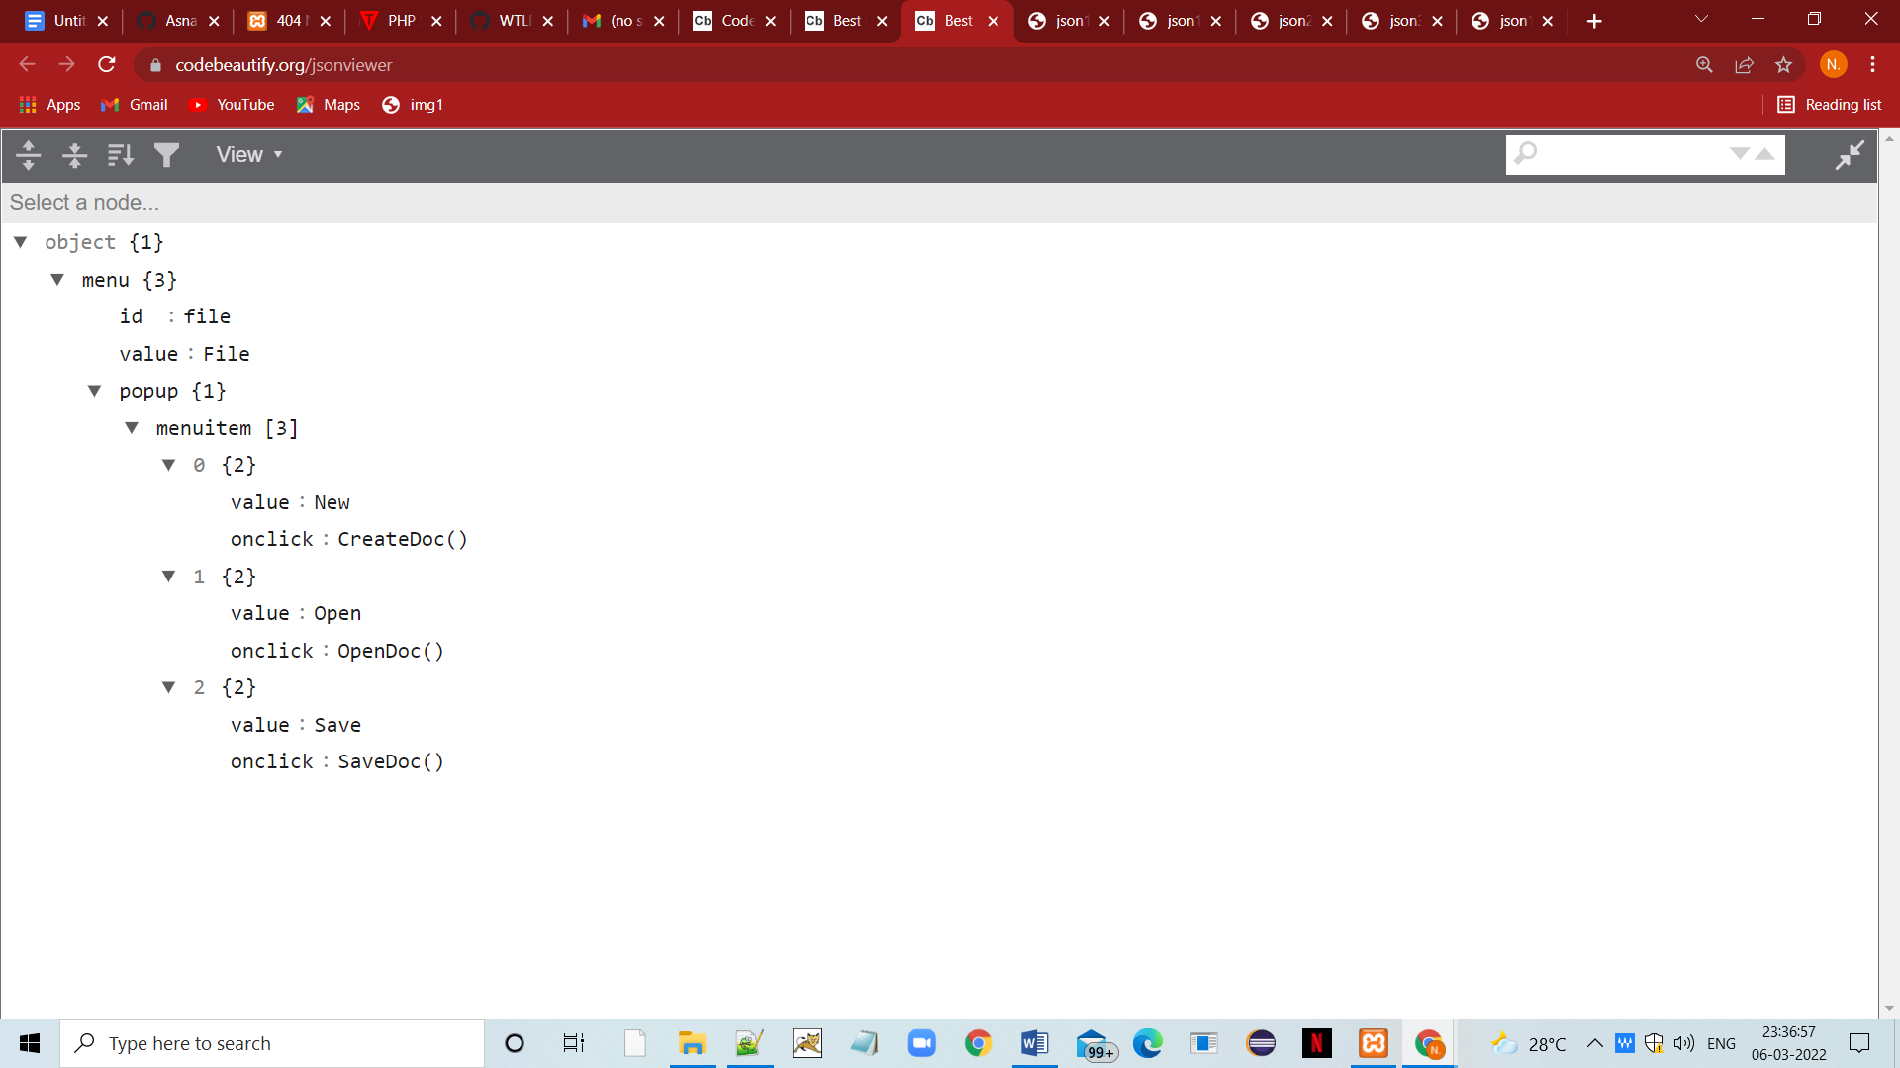

|  |
| --- |
| **PROGRAM #29 03-02-2022** |
| Program to represent PHP JSON String. |

<?php

$json = '{"a":1,"b":2,"c":3,"d":4,"e":5}';

var_dump(json_decode($json, true));//true means returned object will be converted into associative array

?>

**OUTPUT**

